Finding a Parcel
- Go to the APO Screen – APO stands for Address, Parcel and Owner
- Within the Parcel section, enter the search information and hit the Submit
  - Enter the Parcel # without the dashes
  - Or enter the Street # and Street Name
- In the result list, select the Parcel # to work with

Adding Conditions to a Parcel
- In the Detail portion of the screen, click on the Conditions tab

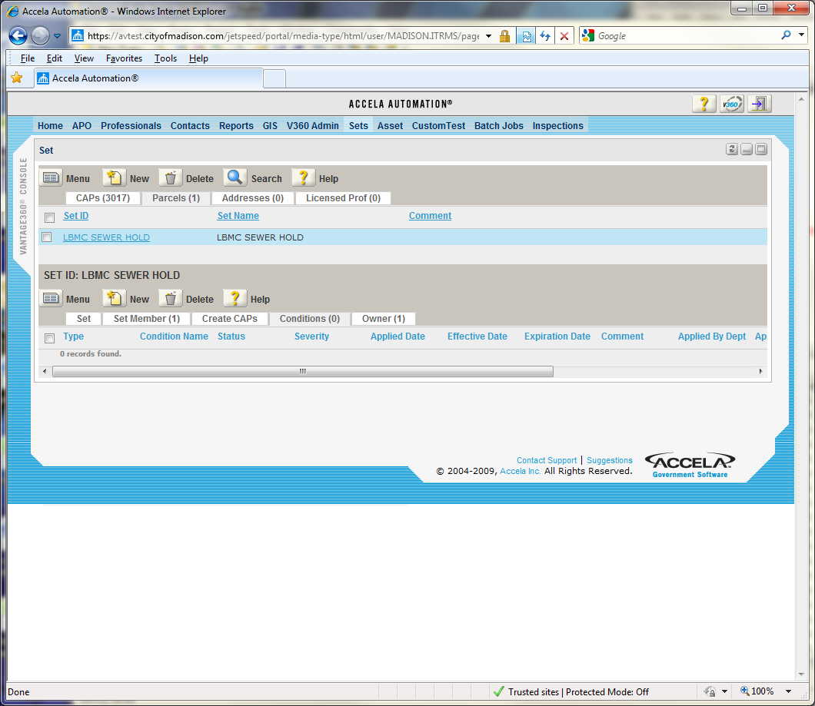
- Click on the Conditions Tab
- Hit the New button to add a Condition

- Click on the Standard Condition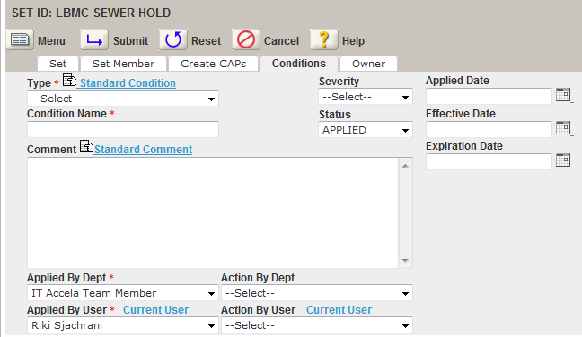
- In the Type drop down list, select ENGINEERING HOLDS
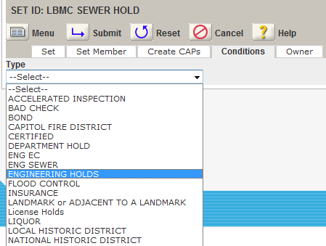
- Hit the Submit button
- Select the Condition Name; for example Sewer Fees
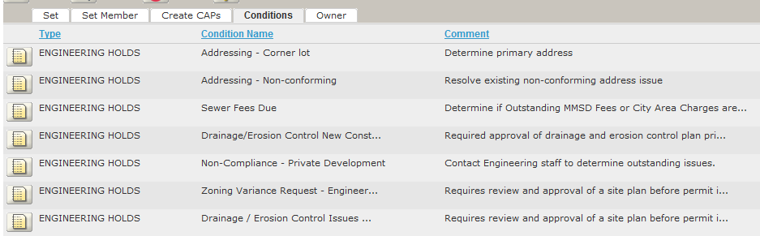
- Edit any additional information as needed
  - Enter a Applied Date of today
  - Make sure the “Applied By User” is yourself. Click on the Current User link to auto-populate this
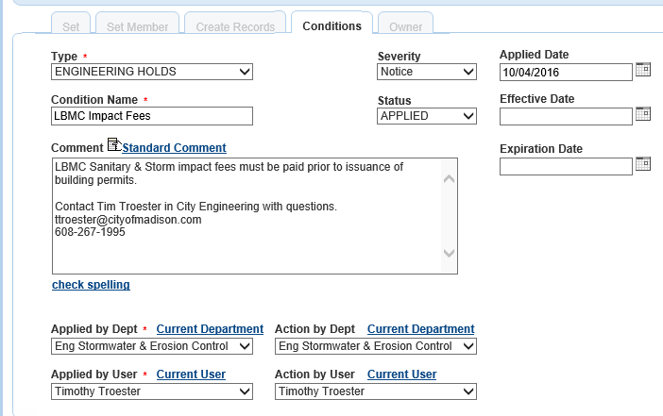
- Hit the Submit button
- Repeat steps 6 thru 12 to create additional conditions

Managing Parcel Conditions
- To remove the Condition, change the status to RELEASED

Adding the same Condition to multiple Parcels

- Go to the Sets screen
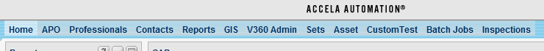
- Click on the Parcels(x) tab
- In the upper portion of the Parcel Set locate the Set to work with
- In the lower portion of the Parcel Set is the detail window
  - The Set Member tab contains a list of all the Parcels
  - The Create CAPs tab is used to create new CAP(s) against the list of Parcels
  - Conditions tab is used to add a Condition to all the Parcels
  - Owner tab is a consolidated list of unique owners across all Parcels in the List
- Adding Parcels to the list – There are three main ways: one by one, using the map, or submit a ticket with a spreadsheet of parcels
  - Adding Parcels one by one
    - Go to the Set Member tab
    - Click the “Look Up”
    - Enter the Parcel Number or address
    - Check the boxes of the parcel numbers to add
    - Click the “Select” button
    - Repeat this for all the Parcel numbers
  - Adding Parcels using the Map
    - Go to the Set Member tab
    - Click on the “GIS Import” button
    - Navigate and zoom to the area that contains the parcels
    - On the Left tool bar, use the “Select by Rectangle” or “…Line” or “…Polygon”
    - Click and drag over the Parcels to add to the Set. You can only add 100 parcels at a time
    - In the right Contents, Click Actions > Send GIS Features
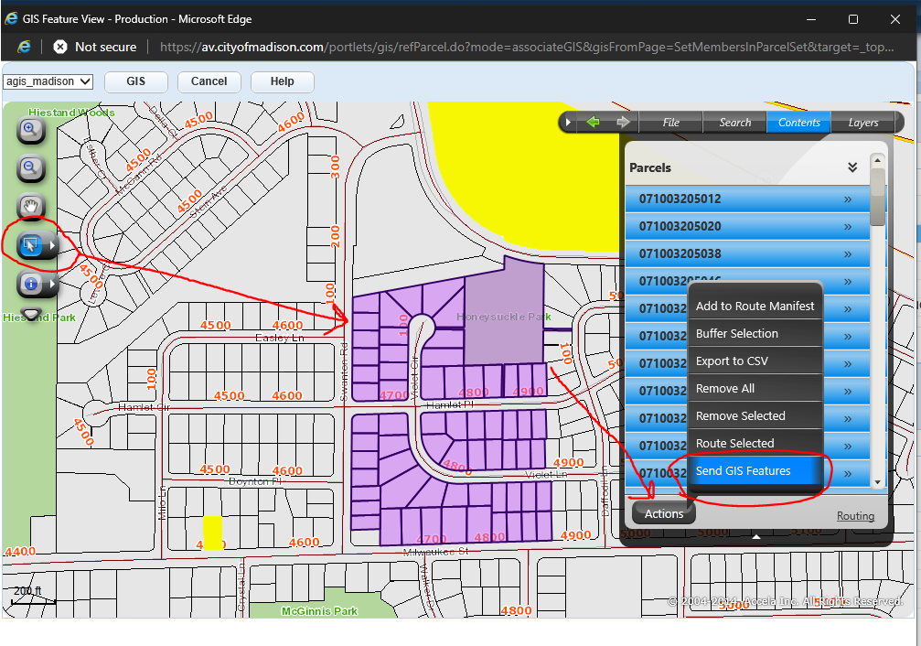
    - Use the top left checkbox to check all the Parcels, then hit the Select Button to add them to the Set
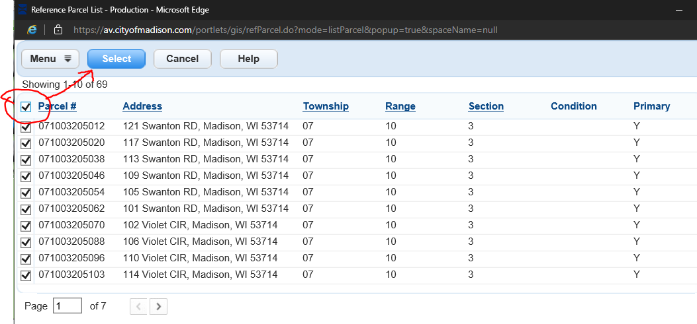
    - It will not allow duplicate Parcels
  - Lastly, if there are more than a thousand parcels, or it would be too difficult to add them manually or through the map. You can send a Ticket and include a spreadsheet with all the parcels and mention the Set ID they should be added to.
- Click on the Conditions Tab
- Hit the New button to add a Condition

- Click on the Standard Condition
- In the Type drop down list, select ENGINEERING HOLDS
- Hit the Submit button
- Select the Condition Name; for example Sewer Fees
- Edit any additional information as needed
  - Enter a Applied Date of today
  - Make sure the “Applied By User” is yourself. Click on the Current User link to auto-populate this
- Hit the Submit button
- Repeat steps 6 thru 12 to create additional conditions

