
Department of Public Works
PROJECT CONTACTS
- Project Manager: Grecia Izquierdo-Torres, 608-266-4763, gizquierdo@cityofmadison.com
- Construction Inspector: Chris Horst, 608-520-2384, chorst@cityofmadison.com
- Parisi Construction: Taylor Matushak, 262-468-1535, TMatushak@walbecgroup.com

Engineering Division

Construction Fact and Details Sheet:
Virginia Ter, Norwood Pl, Rugby Row, Hillington Way Construction Project
Project Location Map

Construction Schedule & Impacts
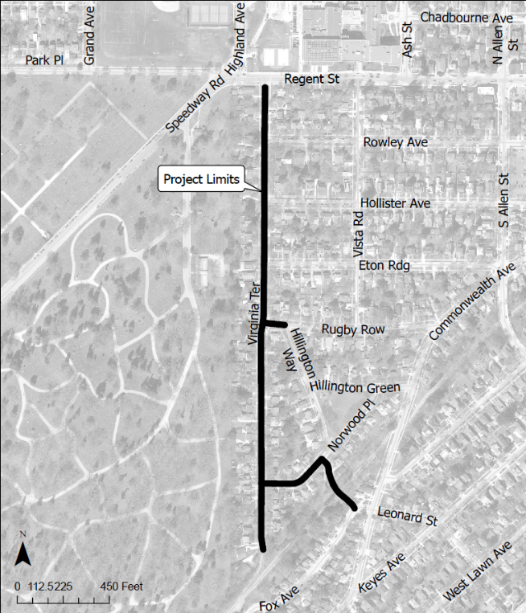
Construction Schedule: Work is scheduled to begin the week of August 3, 2026 and the project is expected to be completed in August of 2027.

Once construction ends in the fall of 2026, all the streets within the project limits will be required to have an asphalt surface for the winter.

Traffic Impacts: Virginia Terrace, Norwood Place, Rugby Row, and Hillington Way will be closed to all traffic until the project is complete. Local access will be provided, but driveways may not be accessible at times when work is being performed in front of the driveway and while new curb and gutter, sidewalk, and driveway aprons are constructed. Driveway closures may last up to a cumulative total of 20 days. No parking is allowed within the construction zone during working hours (7AM to 7PM), so when driveways are inaccessible, residents will need to park on the adjacent streets outside the limits of construction. The contractor will notify impacted residents prior to the driveway access being closed for an extended period, but there are likely to be several short-duration closures during utility work and asphalt paving that may not have much advance notice. During these shorter disruptions, the Contractor will work with residents to provide access as quickly as possible. Contact the project manager if you have accessibility concerns and need to request special accommodations.

Regent Street will remain open for two-way traffic for the duration of the project.

The Southwest Commuter Path will remain open at all times. The sidewalk connecting Norwood Place to Fox Avenue, and ramp at the Virginia Terrace cul-de-sac will remain open except when new concrete is being placed and during its cure time.

Construction Sequence: The sequence of construction activities by the contractor are as follows: underground utilities replacement, starting with sanitary sewer main and laterals, water main and services, and storm sewers, excavation and grading of gravel base, placement of concrete (including curb and gutter, driveway aprons, and sidewalk replacements), asphalt paving, and terrace restoration.
- 2026 Construction: The Contractor will start construction with Virginia Terrace from Rowley Avenue to Regent Street with underground utilities replacement, excavation and grading of gravel base, placement of concrete, lower layer of asphalt pavement, and terrace restoration. Additional work might be completed within the project limits.
- 2027 Construction: All remaining work on Virginia Terrace, Norwood Place, Rugby Row, and Hillington Way, as well as the surface pavement for the areas built in 2026.

Water Shut-offs: An average of 2 water shut-offs are expected for each property within the project limits. A minimum of 48 hours of notice will be provided prior to the shutoffs. Each shut off may last up to 8 hours, but typically last 4 hours. The water will be shut off when the new water main is connected to the existing main and connecting the services to the new main. At the start of construction, the existing main will remain in service until the new main is installed and connected. Emergency shutoffs may occur if the old, brittle main is damaged during construction. If this happens, crews will notify affected properties as quickly as possible.

Refuse Collection/Mail Delivery: It will be the contractor’s responsibility to allow for refuse collection and mail delivery to continue during construction. Please mark your address on your cart to make sure it is returned if moved. We ask that you place your carts at the street the evening prior to or at the very latest 6:00 a.m. the morning of your scheduled refuse/recycling day.

Landscaping: Existing landscaping, plantings, raised planting beds, stone or brick pavers, and wood retaining walls, etc. within the terrace (between curb & sidewalk) will be impacted. If you wish to save any landscaping, it should be removed prior to the start of work in 2026 and reinstalled by you after construction is complete. If left in place, these items will be removed by the contractor. The contractor will not replace or reinstall these items following completion of the project.

Project Details – Proposed Work
Sanitary Sewer: The City will replace the existing sewer main 6” clay sewer main along Virginia Terrace (cul-de-sac south of Norwood Place to Regent Street), Rugby Row (Virginia Terrace to Hillington Way), and Hillington Way (Norwood Place to 160ft north) with 8” PVC pipes, and the existing 8” along Norwood Place (Virginia Terrace to Hillington Way) and Hillington Way (Southwest Commuter Path to Norwood Place) with 8” PVC pipes. Work will also include the replacement of laterals from the new main to the property line.

Water Main: The City will replace the existing 8” cast iron water main along Virginia Terrace (cul-de-sac south of Norwood Place to Rugby Row), and the existing 6” cast iron water main along Virginia Terrace (Rugby Row to Regent Street), Rugby Row (Virginia Terrace to Hillington Way), and Norwood Place (Virginia Terrace to Hillington Way) with a new 8” ductile iron water main and will reconnect the water services to the new water main.

Storm Sewer: The City will install a new 30” concrete storm sewer main along Virginia Terrace (200ft north of Norwood Place to 200ft south of Rugby Row) and Hillington Way (75ft south of Norwood Place to Norwood Place), new 24” concrete storm sewer main along Rugby Row (Virginia Terrace to Hillington Way), and new 36” concrete storm sewer main along Hillington Way (75ft south of Norwood Place to Norwood Place). Other storm sewer improvements include private storm sewer connections and replacement of storm sewer in the intersections.

Street: The City will replace the existing asphalt and gravel base along Virginia Terrace (from cul-de-sac south of Norwood Place to Regent Street), Norwood Place (from Virginia Terrace to Hillington Way), Rugby Row (from Virginia Terrace to Hillington Way), and Hillington Way (from the Southwest Commuter Path to Norwood Place). Sidewalk, curb and gutter, and driveway aprons will be spot replaced, which include those in poor condition or removed during utility installation.

Driveway Aprons: Driveway aprons constructed with the project will be replaced with concrete per the City of Madison standard detail. Driveway widths will be replaced per the City of Madison standard detail. Any driveway removal behind the proposed sidewalk will be replaced with concrete or asphalt depending on the existing material.

Bus Pads: Bus pads will not be installed with the project.

Streetlights: There are no proposed changes to street lighting within the project limits.

Trees: Terrace trees are the process of being pruned to provide required clearance for construction equipment. There are 3 planned tree removals (18” American Basswood (509 Virginia Terrace), 36” Pin Oak (453 Virginia Terrace), and 19” Norwood Maple (2505 Norwood Place)) with this project because of poor condition and these trees are planned to be removed ahead of construction. If, during construction, it is determined that any additional trees must be removed, adjacent property owners will be notified prior to removal of the tree. The trees within the project limits that remain may have roots trimmed during construction.

Tree pruning in advance of the project is required to reduce the risk of damage to the trees during construction. The City of Madison Forestry Section will perform the necessary work. For certain species, especially oak and elm trees, the pruning must be completed by June 1st to reduce the chance of disease. If additional trees need to be removed, City Engineering will notify the adjacent property owner prior to removal.

Street trees provide many benefits to our city and are considered an important part of the city’s infrastructure. Forestry Section staff will evaluate the terrace for new planting sites and potential replacement sites when the project is complete. There is no additional cost to the adjacent property owner for tree planting. Street trees are typically planted in the spring of the year following the completion of the construction project. Per Madison General Ordinance 10.10, City Forestry determines tree species and planting locations. Residents cannot choose or plant their own tree in the terrace.

For any questions regarding street tree maintenance or planting, please contact the general forestry line at 608-266-4816.

