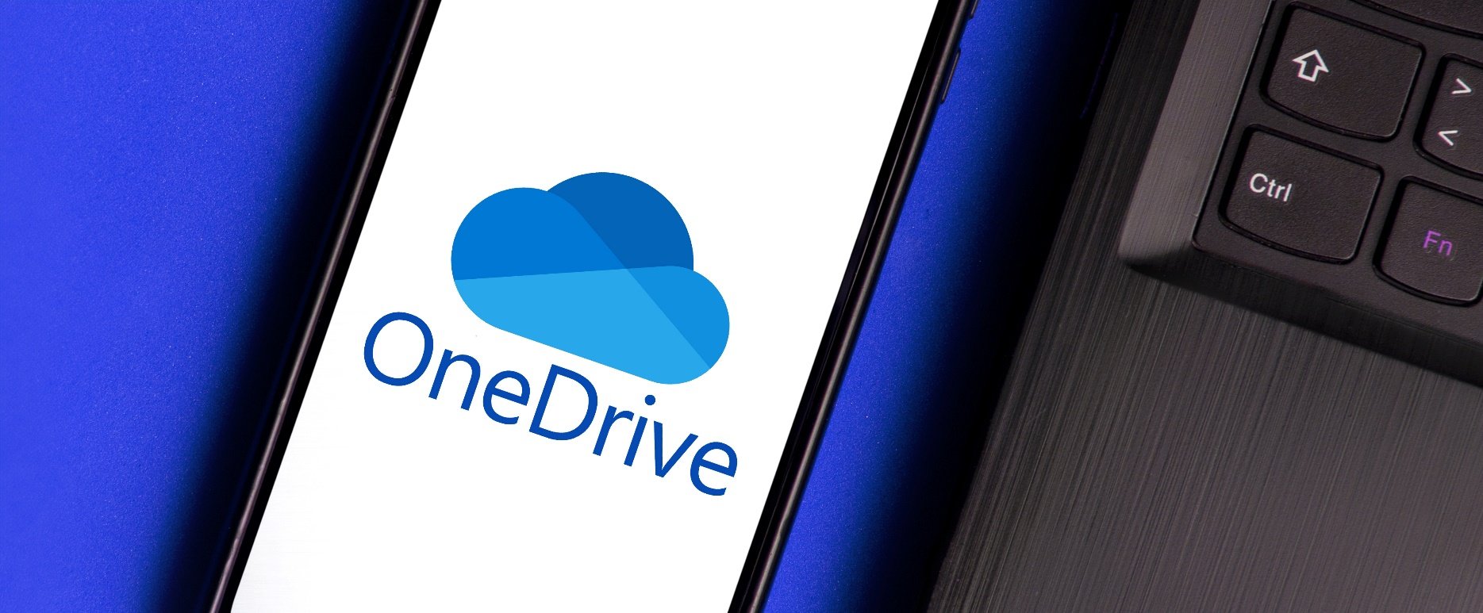


Microsoft Training: OneDrive

Note: Microsoft frequently updates products, often rolling out changes in user interface (UI) and design. We keep our Microsoft support documentation current by updating it periodically. The buttons, menus, or windows may look different, be in a different location, or change on your screen. Features also sometimes change. However, the fundamental steps, workflows, and concepts explained here should still apply. For these reasons, and so that you are accessing the more current version, please save the link to this guidebook rather than downloading it.

Table of Contents
OneDrive Orientation 1
What is OneDrive 1
OneDrive Use Cases 2
Access OneDrive 2
OneDrive Orientation 4
Sort Files 5
View Options 5
Details 5
Basic File Activities in OneDrive 6
Create New Folder 6
Recolor an Existing Folder 7
Create a New File 7
Open a File 8
Upload a File or Folder 9
Download Files 10
Move a File or Folder 11
Delete a File 12
Rename a File 12
Additional File Activities 13
Add a File to Favorites 13
Share Files and Folders 13
Copy a Link to a File or Folder 20
Search 21
Using Office Applications Online 22
Collaboration 22
Notes on Saving and Version History 22
Sync and Backup Folders 23
Online vs Offline Access 24
Sync Folders 25
Manage Backup Folders 26

OneDrive Orientation

What is OneDrive
Most simply put, OneDrive is Microsoft's online file storage solution. OneDrive permits you to access files from multiple devices, and allows file sharing and easy collaboration. OneDrive allows users access from anywhere, anytime, and comes with increased security.

Access files from  any device | Share work product  in real time | Keep files compliant,  secure and protected
- Store all files privately in the cloud  - Securely access files from any location, any time | - Collaborate and co-author in real time  - Share file links with co-workers – no more sending files via email  - Apply access controls and expiration dates to files and folders | - Set sharing permissions (access controls) per files or folders  - All security, compliance and governance managed within OneDrive

QUESTION: What is the difference between OneDrive and SharePoint?
Great question! They are not quite the same. SharePoint is a web-based platform created for managing and sharing content, knowledge, and internal communications. Think of it this way... OneDrive is your personal SharePoint site. SharePoint is the preferred location for shared files.

QUESTION: Will OneDrive replace my U (User) Drive?
Currently there is not an identified retirement date for U (User) drive. OneDrive sites are individual sites and will eventually replace U drives. A OneDrive site is given to new employees as part of the M365 suite of MS Office applications (Outlook, Word, Excel, PowerPoint).

QUESTION: What happens if an employee leaves City employment?
When an employee leaves City employment, OneDrive access is given to the employee’s supervisor for a limited time, and then it is deleted.

QUESTION: How do I access OneDrive?
You can access the desktop version of OneDrive from File Explorer on your City device or access the web version at Office.com on any device. There are some document formatting differences between the two versions, but they both have the same basic functionality. Changes made to files and folders in one version will sync with the other version.
- OneDrive – Desktop/File Explorer
- The OneDrive desktop application has been installed on your device, but it may not be “set up”. If you have not used OneDrive yet, go to Set Up and Install OneDrive for the First Time article in the IT Service Center Knowledge Base.
- Use File Explorer to navigate to your OneDrive and the folders/files you have saved. File Explorer is the folder icon next to or near the start or Windows icon (lower left).
- OneDrive on Office.com
- You will need to be logged in to your City M365 account to access the files from a web browser. The system will prompt you to sign in if necessary. MFA rules apply.
- From the Home page, select the App Launcher – also known as the waffle – in the upper left of the screen. Select OneDrive from the list of apps.

OneDrive Use Cases
OneDrive serves as individual storage space. Use cases at the City of Madison include:
- Documents you create and are collaborating on before sharing to a group/team space.
Reference documents and items sent to you for review.
Business-related personal records such as benefits documentation, position description, etc.
Alternative to personal drives, flash/thumb drives, or other removable drives.

Access OneDrive
- Open your web browser (i.e. Chrome or Edge) and go to office.com.
- Use your organization login credentials to log in.
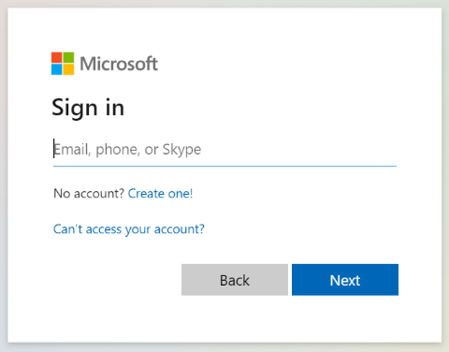
- Select Apps from the Navigation Pane.
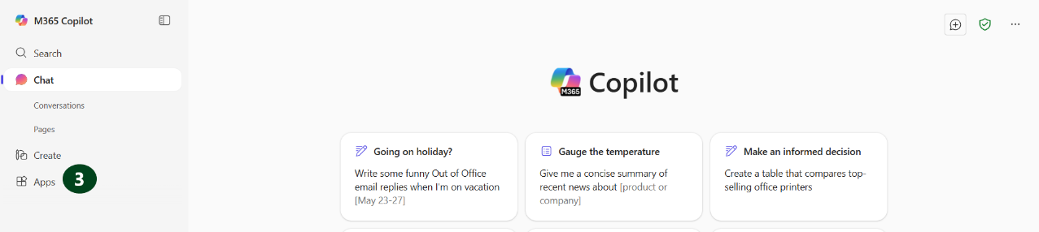

- Select OneDrive.

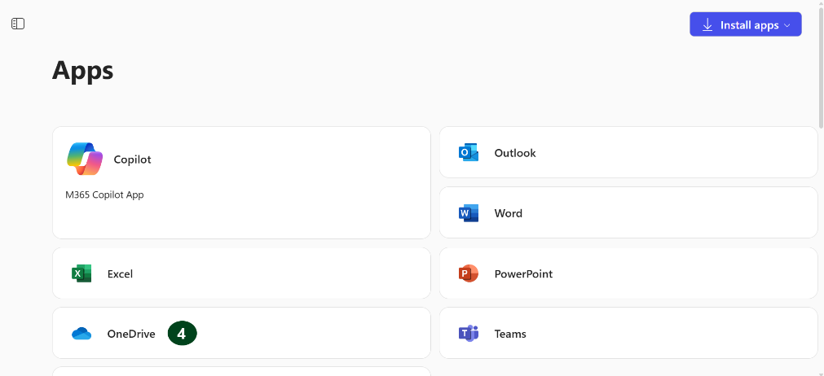

OneDrive Orientation


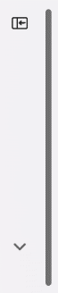
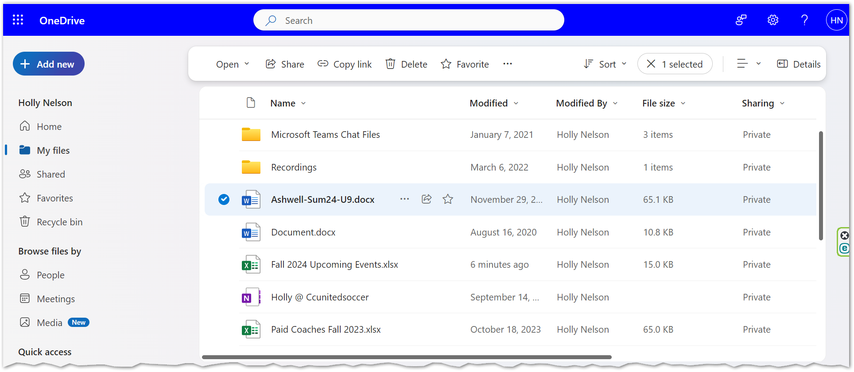
7
2
3
4
5
6
1

- Apps Launcher – Used to access Microsoft Office 365 applications (i.e. Word, Excel, PowerPoint, OneDrive).
- Navigation Pane – Contains a tree view of the contents and quick links to content on your OneDrive.
  - Home – Landing page in OneDrive.
  - My files – Displays your files and folders in OneDrive.
  - Shared – Displays files that have been shared with you or by you.
  - Favorites – Quick access files/folders.
  - Recycle bin – Displays deleted files and folders.
- Quick Access – Frequently used storage locations, including recently used shared libraries, channels, and folders in SharePoint and Teams.

- Hide/Show Navigation Pane – Use the Collapse/Expand button to hide or show the Navigation Pane.
- Toolbar – Displays file options for selected files / folders.
- Search bar – Search for files and folders within your OneDrive.
- File List – Displays files and folders for the option that you have selected in the navigation pane.
- Settings – Use the gear icon to change settings, theme, contact preferences, etc.
- Help – Use the question mark icon to search for help on a certain OneDrive topic.
- Account Manager – Select the name or picture icon to view and change account settings, or to logout of your account.


NOTE: In order for the Toolbar to appear in your display, a file or folder must be selected.

Sort Files

- Select the Sort button from the toolbar.
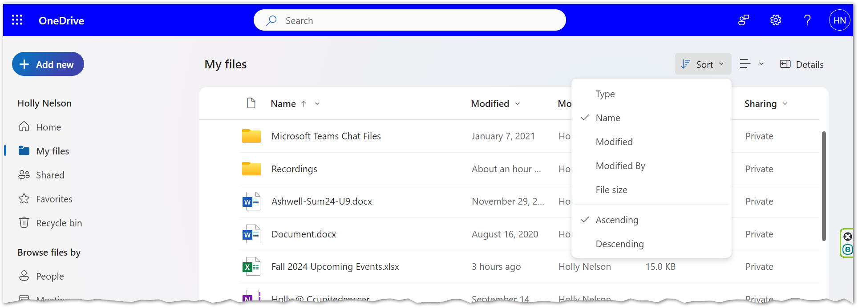
2
1
- Choose the field to sort on from the top half of the dropdown menu. Choose Ascending or Descending from the bottom half of the dropdown menu.

View Options
- Select the Switch View Options button from the toolbar.
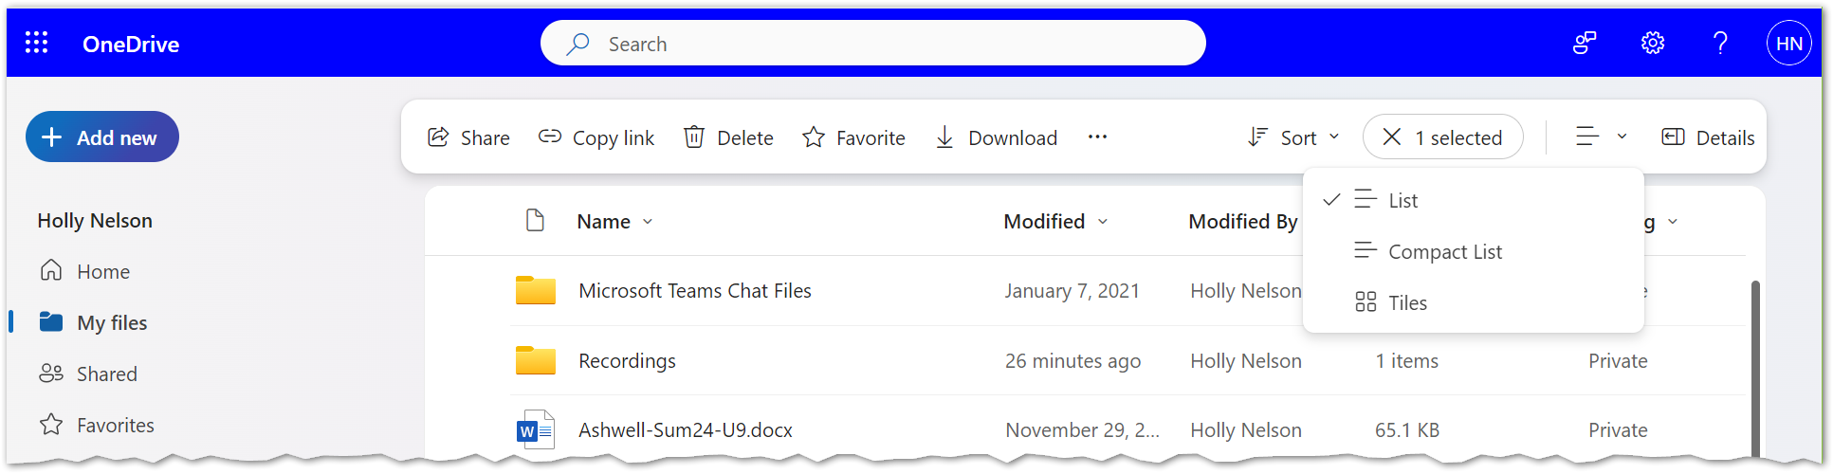
1
3
2
- Choose one of the three view options:
  - List: display contents as a list.
  - Compact List: display contents as a list with compacted row height.
  - Tiles: display files as image thumbnails.

Details
- Choose the Details button from the toolbar.
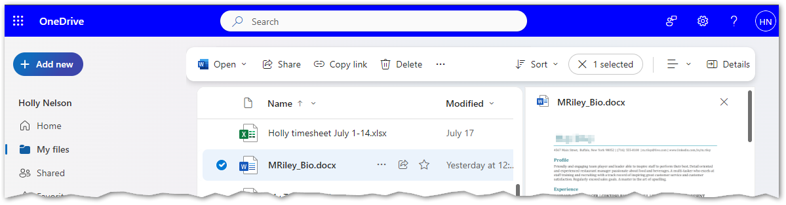
2
1
- This shows a preview of the document along with the ability to manage access.

Basic File Activities in OneDrive

Create New Folder
- Select the Add New button from the Navigation Pane.
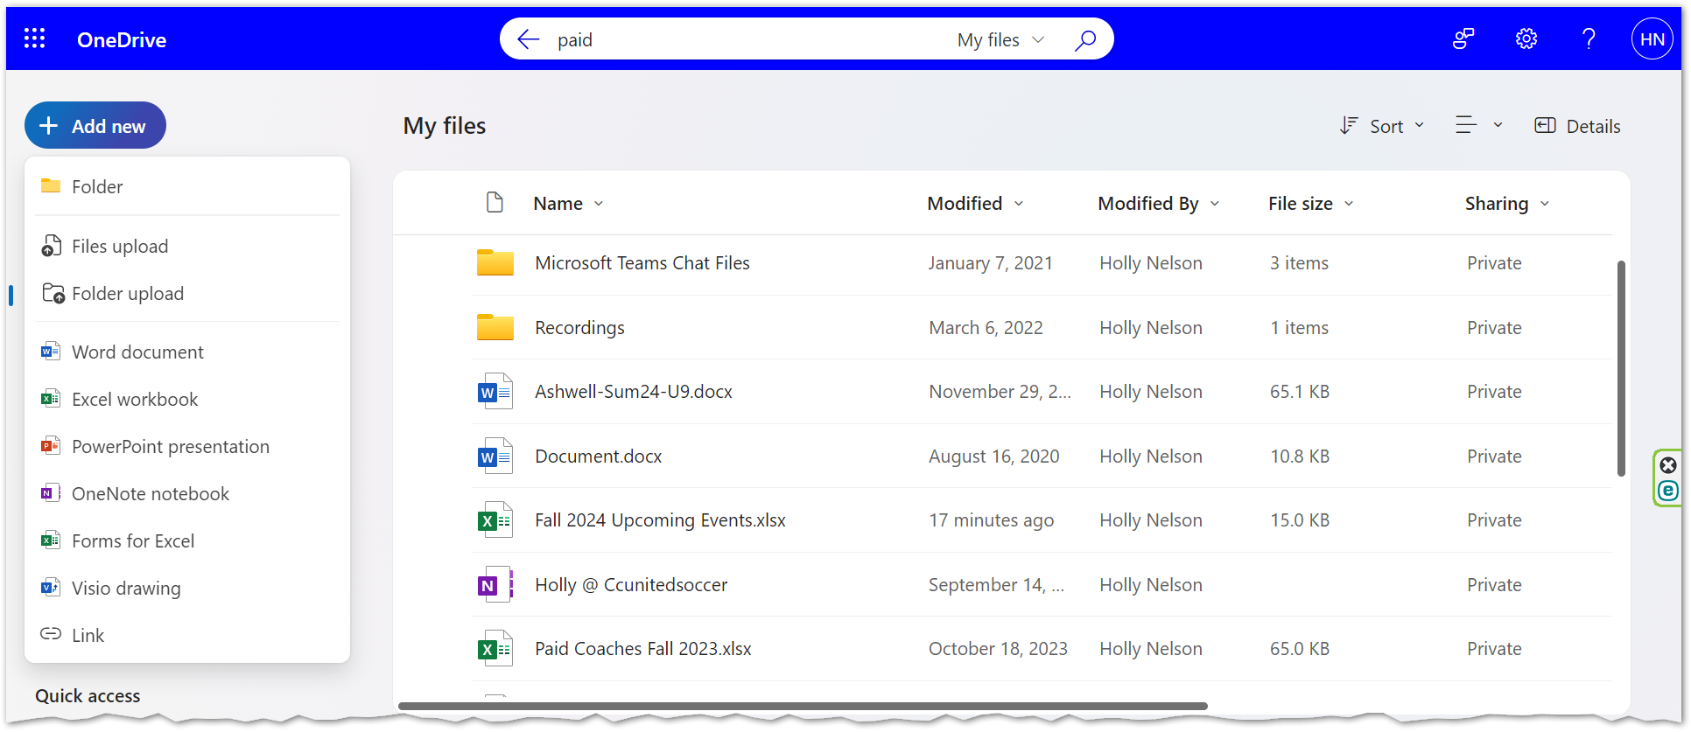
1
2
- Choose Folder.
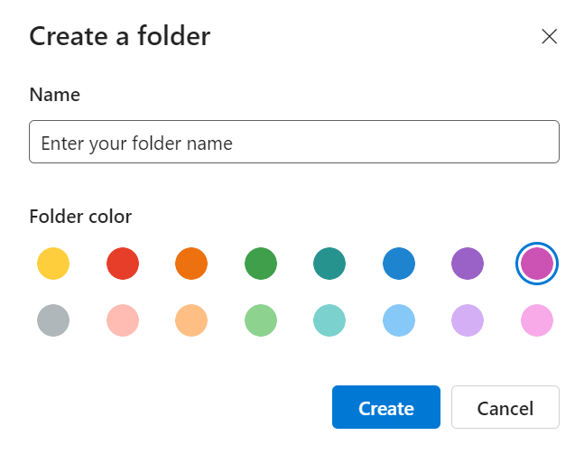
- Name the folder and choose a color.
- Select Create.


TIP: The new folder color coding options help create a visual distinction that makes content more accessible to find and organize. Try to use colors consistently across your folder structure.

Recolor an Existing Folder
- Right-click an existing folder.
- Choose Folder Color.
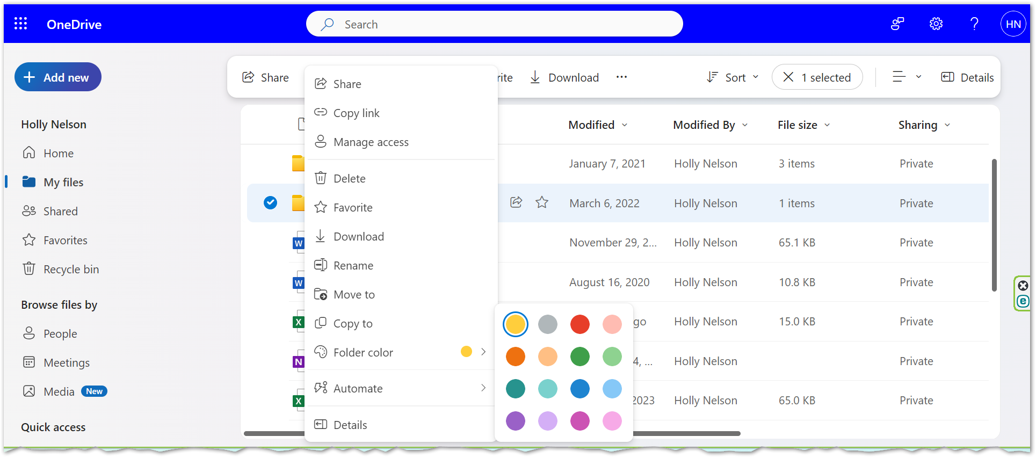
3
2
1
- Select a color.

NOTE: There may be older folders (from 2019 and before) that may not have the re-color option available.

Create a New File
- Select the Add New button from the Navigation Pane.
1
2
- Choose an application by which to create the new file.
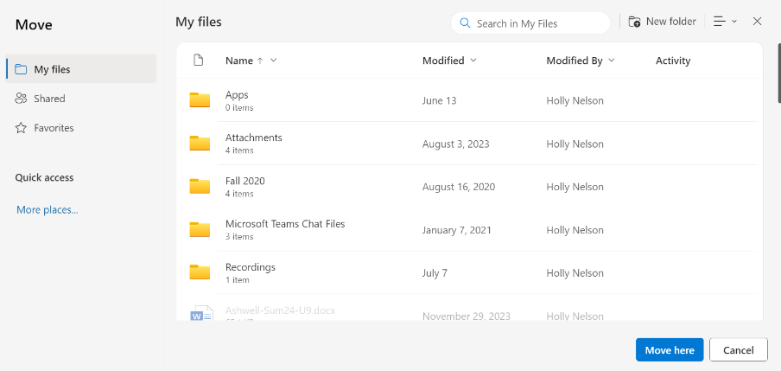
- Save the file by selecting the dropdown arrow next to the temporary file name in the upper left corner of the window.
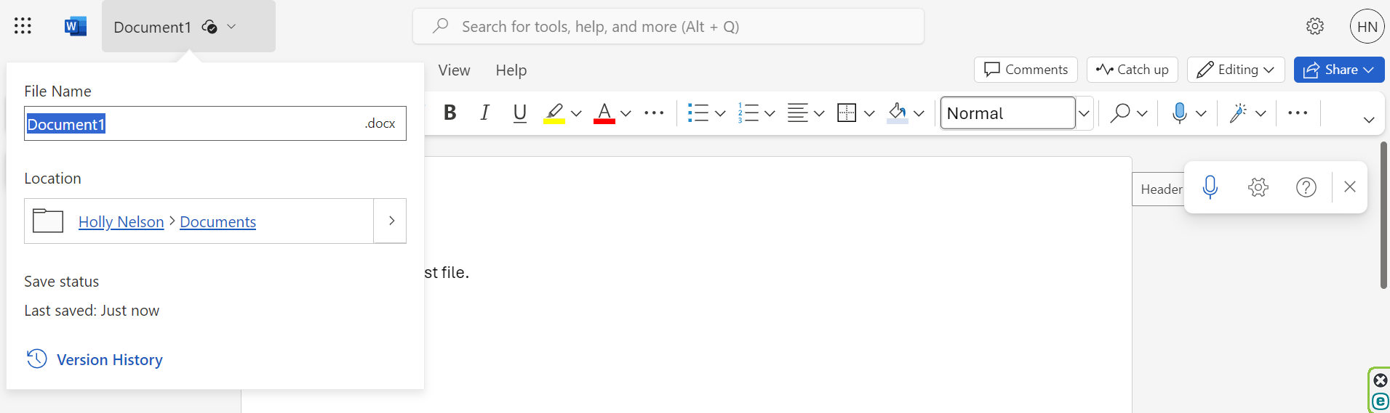
5
4
6
3
- Type a name for the file.
- Select the Location arrow.
- Choose a location to store the
file.
7
- Select Move Here.
NOTE: File changes are automatically saved by default using the web version of a Microsoft Office application. The Microsoft Office desktop version of applications have an on/off toggle for AutoSave as well, found as the first button on the Quick Access toolbar.

TIP: You may need to select the Refresh button in your web browser to display a newly created file in your OneDrive window.

Open a File
- Select a file from My Files using the file selection option.
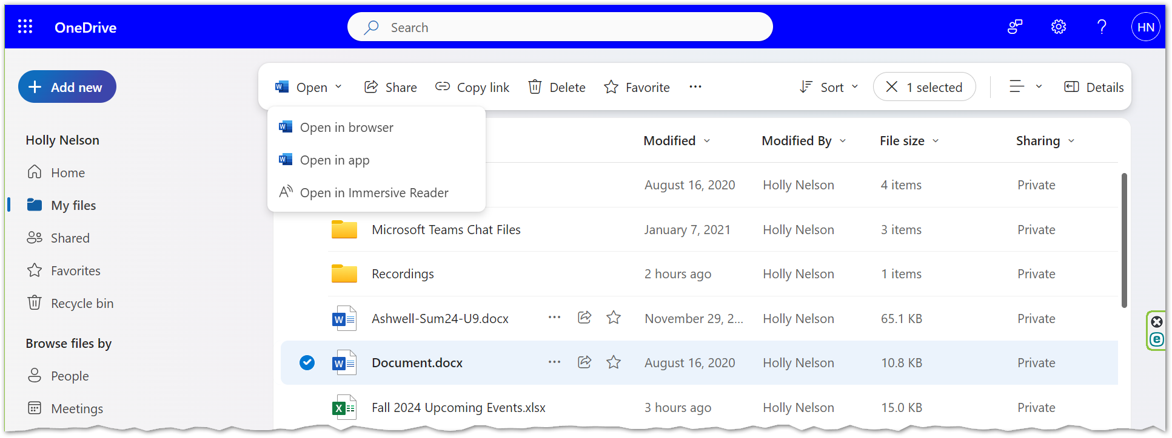
3
2
1
- Select the Open button from the toolbar.
- Choose to either Open in browser or Open in app.

TIP: You can also use the More (...) button to the right of the filename, choose Open and select to Open in browser or Open in app. Review the Using Office Applications Online section in this guide for more details on working in your browser.

Upload a File or Folder

Upload from within OneDrive
- Navigate to the OneDrive folder where you wish to upload a file or a folder.
- Select the Add New button from the Navigation Pane.
2
3
- Choose Files upload.
- Navigate to and select the file you wish to upload.
- Select Open.

TIP: You can also choose to upload a folder and its files as well. Select Add New and choose Folder upload. Navigate to and select the folder you wish to upload and select the Upload button.

NOTE: Depending on the web browser, upload files up to 250GB in size. (This limit is per file, not total.) Recommended web browsers are Chrome or Edge.

Upload a File to OneDrive using File Explorer
- Navigate in File Explorer to the location where your file (to upload) is located.
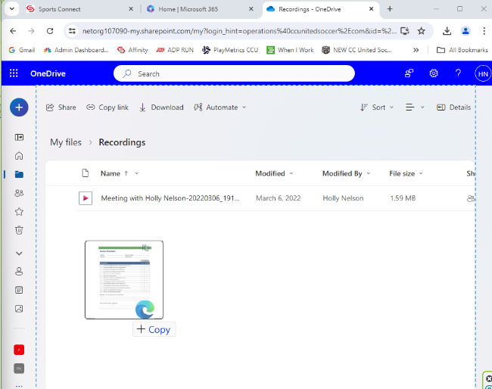
- Navigate to the OneDrive folder where you wish to upload a file or a folder.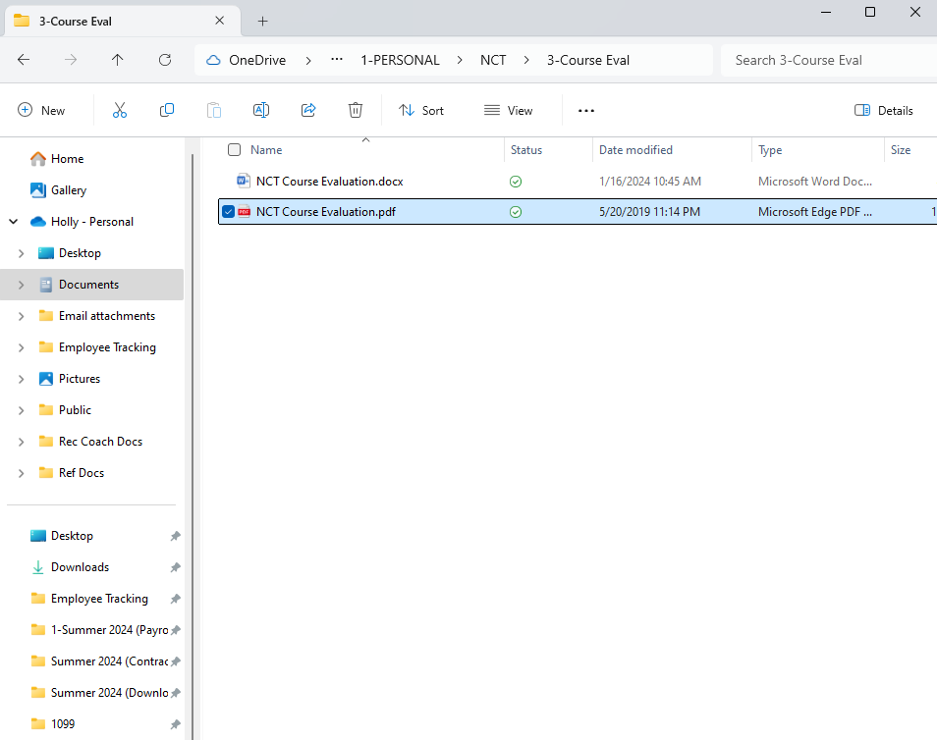
OneDrive
File Explorer
- Drag and drop the file from the File Explorer window to the OneDrive window.

Download Files
NOTES: You will most likely only use the Download feature on rare occasions, such as making the file available offline when online access isn’t available or stable.

Please be aware! Downloading multiple copies of files (as well as emailing copies of files) is not a best practice. Duplicated files take up more cloud space and contribute to our digital carbon footprint.

You can't download files directly from the Shared view. You will need to open the file and save a copy in the location of your choice.

- Select a file (or files) from My Files using the file circle check box selection option.
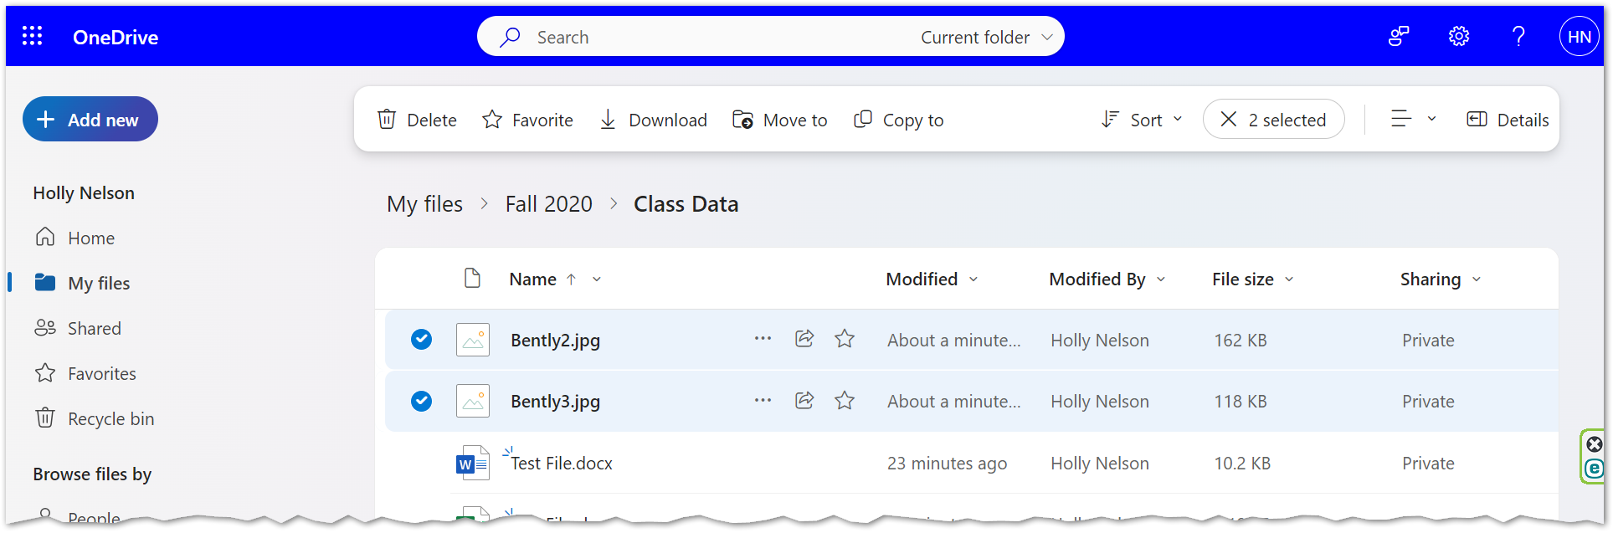
1
2
- Select the Download button from the toolbar.
- Files will download to the computer hard drive into the Downloads folder. If you selected more than one file, all files download into one .zip file.

Move a File or Folder
NOTE: Move files/folders to OneDrive from your U drive or other location rather than syncing. The City of Madison’s guidance: First, clean up your U drive! Second, move applicable files to OneDrive. The City of Madison will NOT be syncing the U drive with OneDrive.

- OneDrive at office.com
  - Depending on the web browser, upload files up to 250GB in size. (This limit is per file, not total.) Recommended web browsers are Chrome or Edge.
- File Explorer
  - Copy or move files between folders within OneDrive, or from other folders on your computer. (When files from other folders on your computer are moved to a OneDrive folder, the files are removed from your computer and added to OneDrive.)
- Desktop App
  - Recommended for transferring large files or many files to OneDrive rather than using the Upload button on office.com.

- Select a file (or files) from My Files using the file circle check box selection option.
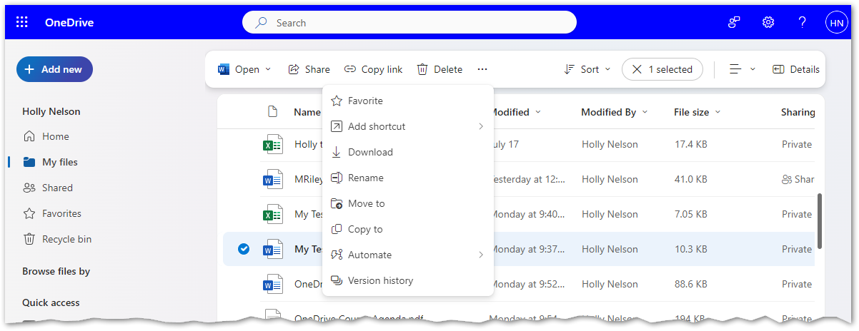
2
2
1
- Choose the Move to button from the toolbar. Depending on your window size you may need to choose the More (…) button from the toolbar first, then choose Move to.
- Navigate the folder structure to choose a location to store the file.
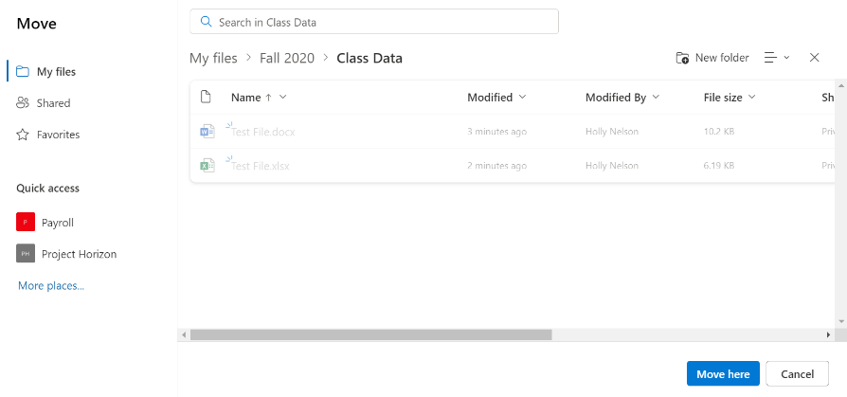
4
3
- Select Move Here.

Delete a File
- Select a file (or files) from My Files using the file circle check box selection option.
3
2
1
- Select the Delete button from the toolbar. You will be asked to confirm deletion.
- The deleted file moves to the Recycle bin. You can restore the file if desired.

NOTE: When a file or folder is deleted on OneDrive within one device, it is deleted off all other devices as well.

Rename a File
- Select a file (or files) from My Files using the file circle check box selection option.
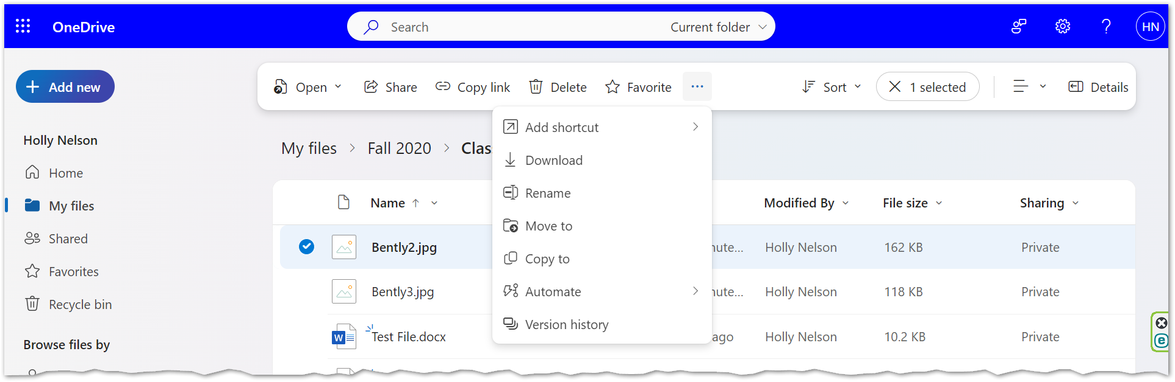
2
2
1
- Choose Rename. Depending on your window size you may need to choose the More (…) button from the toolbar first, then choose Rename.
- Rename the file and select Update.
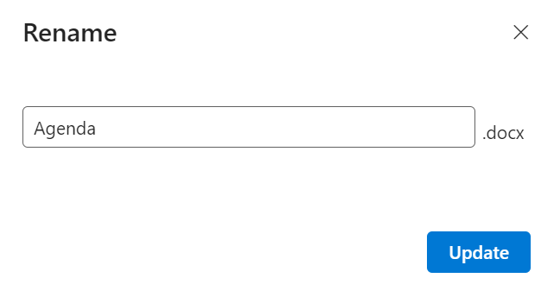
3

Additional File Activities

Add a File to Favorites
Adding files and folders to your Favorites allows you to quickly and easily access frequently used files, items that are difficult to locate, and files that are buried multiple folders deep.

- Select a file or folder (or multiple files of folders) from My Files using the file circle check box selection option.
2
1
2
3
- Select the Favorite button from the toolbar. You can also choose the star button to the right of the filename.
- Choose Favorites from the Navigation Pane to find files and folders you have pinned here.

Share Files and Folders
NOTE: End-users are able to grant access to their OneDrive files/folders to members of our City of Madison tenant, and current or new guest users.

City of Madison’s expectation on file sharing:
- You can easily share and collaborate internally on files / folders from anywhere with an Internet connection.
- You cannot share a file on OneDrive outside of your organization or with people external to the City of Madison workforce unless they are an approved guest user.
  - For more information on guest users/accounts, go to Network and Microsoft Account Management Policy in the IT Service Center Knowledge Base and scroll to M365 Guest Accounts.

Share from OneDrive
- 8Select a file or folder from My Files using the file circle check box selection option.
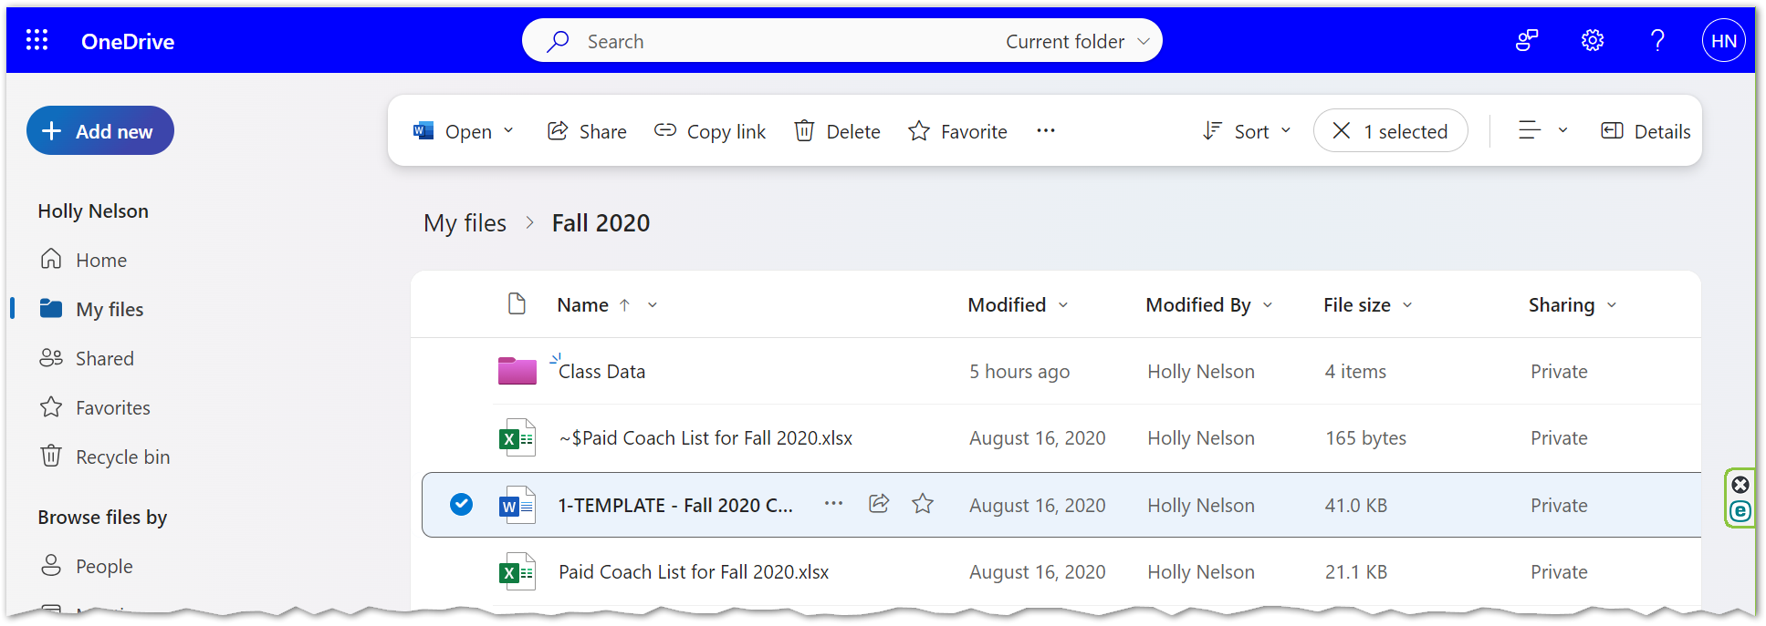
2
1
- Select the Share button from the toolbar.
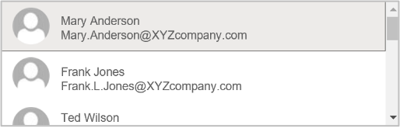
- Enter the name, group or email of the person(s) you wish to share the file with.
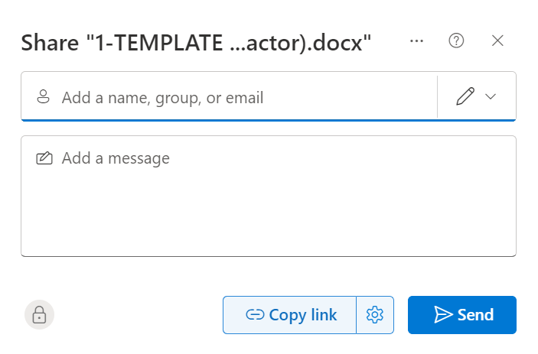
3
4
- Select the appropriately matched name from the selections provided. If the appropriately matched name doesn’t appear, type the entire email address.

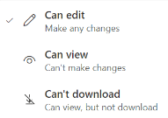
- Select the Edit options dropdown arrow.
8
7
5
6
- Select one of the following options: “Can edit”, “Can view” or “Can’t Download”.
- Add a message about the context of the file share.
- Choose the Link Settings (gear) button.
- Choose an expiration date, if desired.
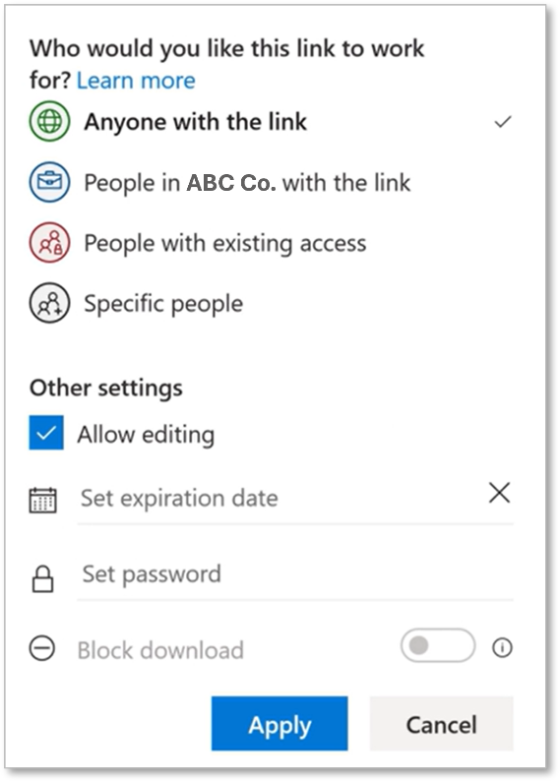
Anyone with the link
12
11
10
9
- Set a password, if necessary.
- If you wish to block shared users from downloading the file, you must uncheck Allow editing to activate the Block download option.
- Select Apply.
- Select the Send button.
13

Unshare Files or Folders
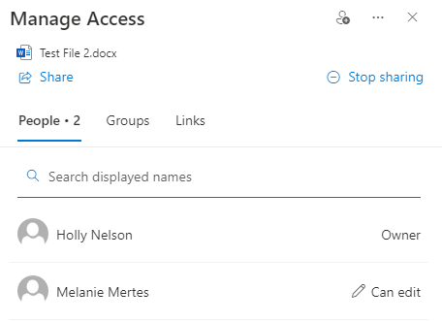
- Select Shared in the Sharing column of your My Files
file list. You can change permissions or Stop Sharing.

Share from File Explorer
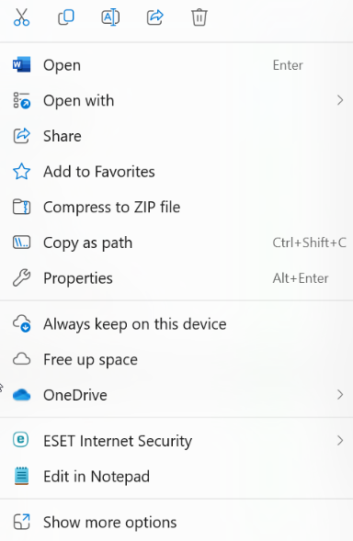
- Open File Explorer by selecting the yellow file folder in the Windows Taskbar.
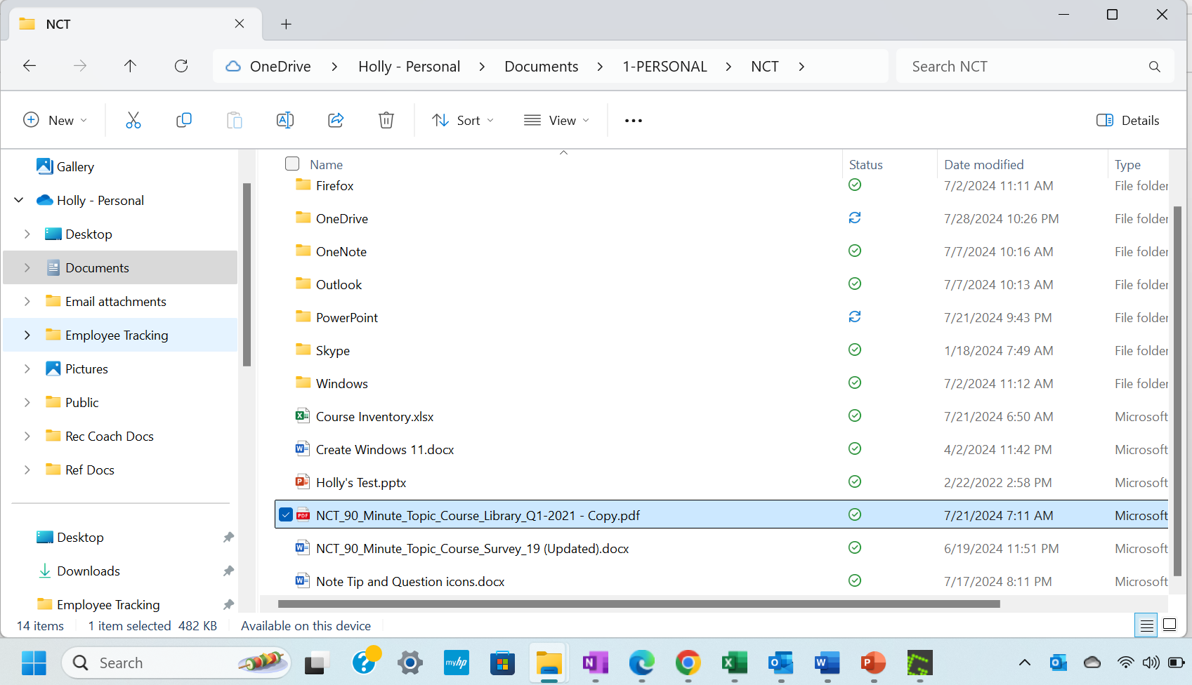
22
OneDrive
1
3
- OneDrive is integrated with Windows File Explorer and is listed as a drive in the navigation pane tree view in File Explorer.
- Right-click a file and choose Share.
- Select the Anyone with the link can edit option.
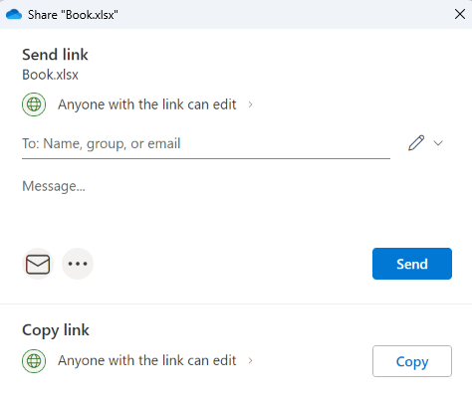
4

- Select Specific people. Leaving the Share the link with setting at Anyone will allow recipients the ability to forward the link to others, and anyone who receives the link will be able to view and access the content. If you opt to leave the Share the link with option at Anyone, you have the option to set a password in More settings.
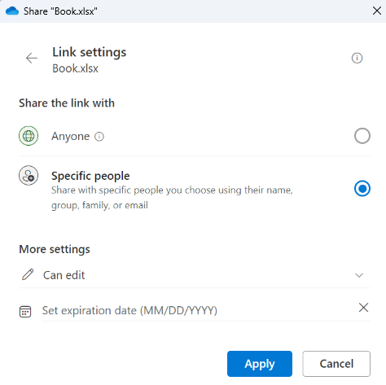
5
7
8
6
- Select the Edit options dropdown arrow. Select one of the following options: “Can edit” or “Can view”.
- Choose an expiration date, if desired.
- Click Apply.
- Enter the name, group or email of the person(s) you wish to share the file with. Select the appropriately matched name from the selections provided. If the appropriately matched name doesn’t appear, type the entire email address.
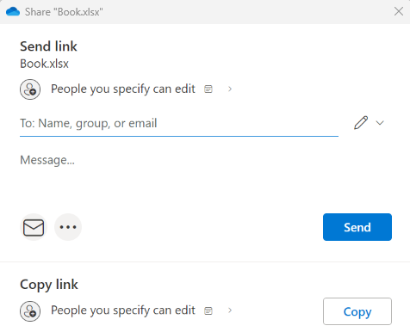
11
10
9
- Add a message about the context of the file share.
- Select the Send button.

Share from within Microsoft Applications
- From within a Microsoft application, select the Share drop-down button from the upper right corner of the application window.
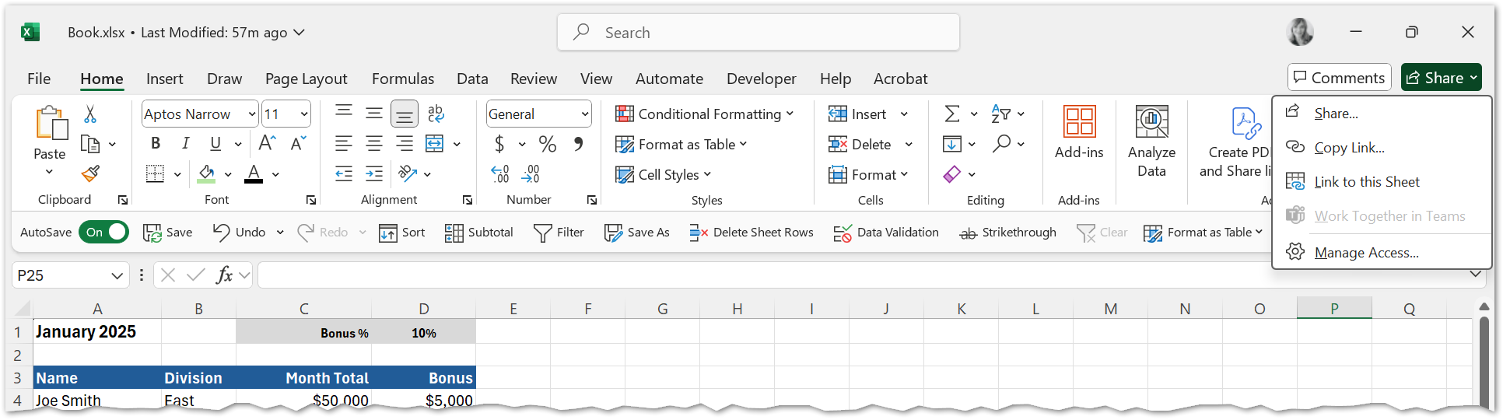
2
1
- Choose Share.
- Select the Anyone with the link can edit option.
3
- Select Specific people. Note: Leaving the Share the link with setting at Anyone will allow recipients the ability to forward the link to others, and anyone who receives the link will be able to view and access the content. If you opt to leave the Share the link with option at Anyone, you have the option to set a password in More settings.
5
7
6
4
- Select the Edit options dropdown arrow. Select one of the following options: “Can edit” or “Can view”.
- Choose an expiration date, if desired.
- Click Apply.
- Enter the name, group or email of the person(s) you wish to share the file with. Select the appropriately matched name from the selections provided. If the appropriately matched name doesn’t appear, type the entire email address.
10
9
8
- Add a message about the context of the file share.
- Select the Send button.

Copy a Link to a File or Folder

Copy a Link from OneDrive
- Select a file or folder from My Files using the file circle check box selection option.
2
1
- Select the Copy Link button from the toolbar.
- Move to where you wish to paste the link (for example an email or a document).
- Press CTRL+V to paste the link to the file.

Copy a Link to a File from within a Microsoft Application
- From within a Microsoft application, select Share drop-down button from the upper right corner of the application window.
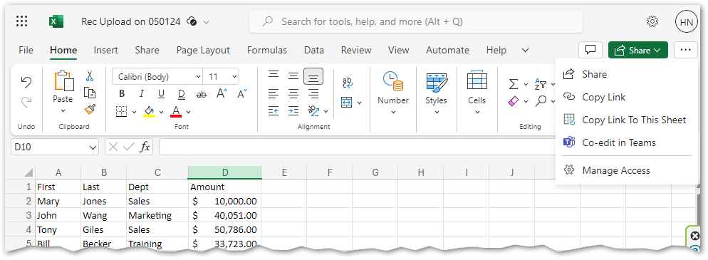
2
1
- Choose Copy Link.
- A dialog box will open. Choose Copy. Then close the dialog box.
- Move to where you wish to paste the link (for example an email or a document).
- Press CTRL+V to paste the link.

Search
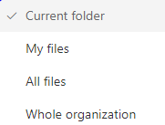
- Click your mouse in the Search box at the top of the OneDrive window.
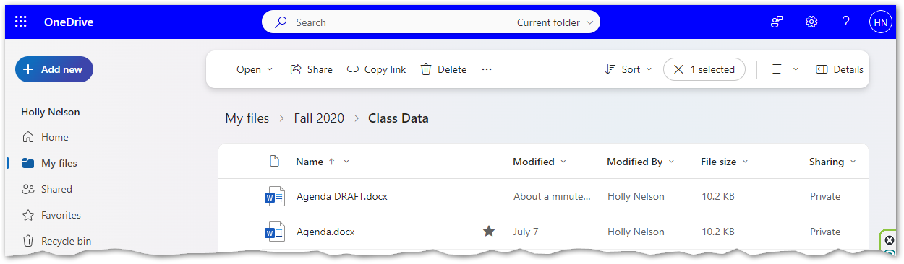
2
1
- You can also search beyond the confines of the current folder. Select the Current folder dropdown arrow for other search location options. Only files you have permission to will appear in the search results.
- Type part of the filename, folder name, or content found within a document.
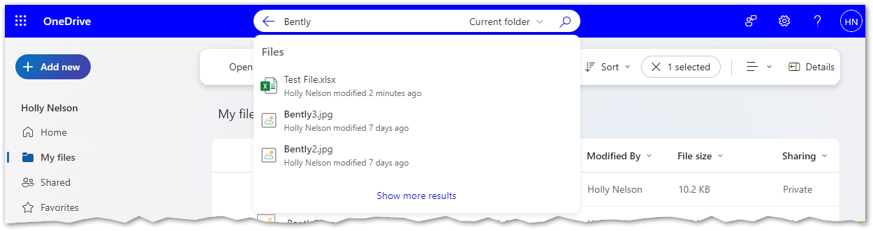
5
4
3
- As you are typing you will find a list appear that matches your search criteria.
- Select Show more results at the bottom of the list to view all matching results.
- If you wish to open the file, simply select the filename in the list and the file will open in a new tab.
OR
- Right-click the filename and choose how you wish to open the file, or choose one of the link options.
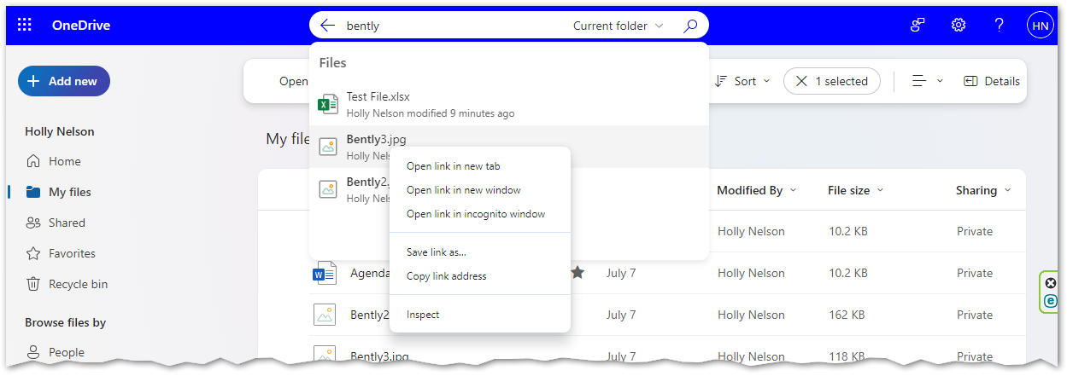
7

Using Office Applications Online

Collaboration
With Microsoft 365 and OneDrive (or SharePoint), multiple people can work together on a Word document, Excel spreadsheet, or PowerPoint presentation.
When everyone is working at the same time, that's called co-authoring, or real-time collaboration.
Microsoft Word, Excel and PowerPoint 365 all support co-authoring.
Co-authoring is only supported on modern file formats including: Word .docx , Excel .xlsx, and PowerPoint .pptx.
All co-authors must have permission to access and edit the documents.
When you are editing a file, you might receive notification that others are working in the file as well. You can edit the file as you normally would.
Locate user initials in the top right corner of the window of others working in the document at the same time as you. Microsoft Office also alerts you to their presence with a color indicator and their name, and actually shows you where in the file they’re working.

Notes on Saving and Version History
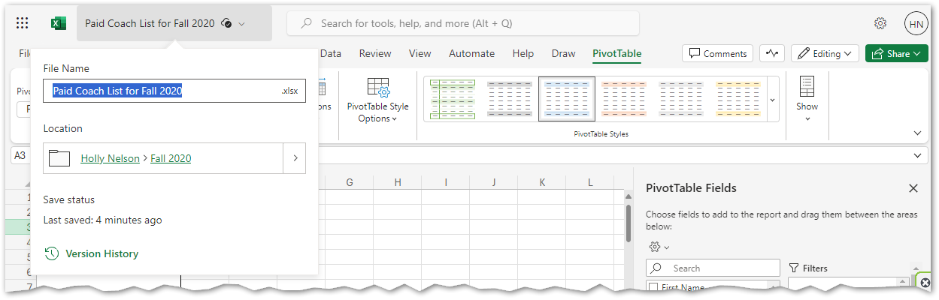
2
1
4
3
- Select the filename dropdown arrow from the upper left corner of the window.
- You can rename the file in the top menu and/or choose a new file location.
- When working in the browser there is no need to save the file. Your application will automatically save. View the Save status information. Note: The Microsoft Office desktop version of applications have an on/off toggle for AutoSave as well, found as the first button on the Quick Access toolbar.
- You can easily find the file version history.

Sync and Backup Folders
QUESTION: What is Sync?
- The synchronization (sync) of files between your computer and OneDrive document libraries.
- Sync means that files/folders stored in your OneDrive are automatically kept up-to-date across all your devices.
    - If you update/edit a document on your computer/laptop, the updates will automatically sync to OneDrive. This means those updates will be available to you from any other device, and to all others that have access to the file.

QUESTION: Can I sync files from all my drives and devices with OneDrive?
- Syncing is only possible from your computer/laptop, not from networked or peripheral devices such as a thumb/flash drive, external hard drives, F or U drives.

QUESTION: When does syncing take place?
- Synced files will update continuously when the computer/laptop is connected to the internet. The computer does not need to be connected to the City of Madison network.

QUESTION: What is OneDrive Backup?
- Backup is available for folders that are on your computer’s hard drive or C: drive – Desktop, Pictures, Documents.
- OneDrive backup moves the folders from your computer to the OneDrive cloud so you can access them anywhere.
- This backup is primarily used to recover the folders if your laptop/device is stolen, lost, or damaged.

Online vs Offline Access
Whenever you open a OneDrive-based file from File Explorer and then save it, your changes are automatically synchronized back to the cloud.

Offline access works by syncing your files between the web and your hard drive.

FILE STATUS ICON COLOR | MEANING
Blue cloud icon | The file is in OneDrive, but not yet on your device.
Green checkmark icon | The file is available for offline use.
  Red X icon | Something went wrong with syncing. You will need to check the error message.
  People icon | The file or folder is shared with others.
Blue arrows icon | The file or folder is being changed, such as when it's being uploaded or downloaded.
Solid green checkmark | The file is in OneDrive and downloaded to your device. You can access the file without Internet access.

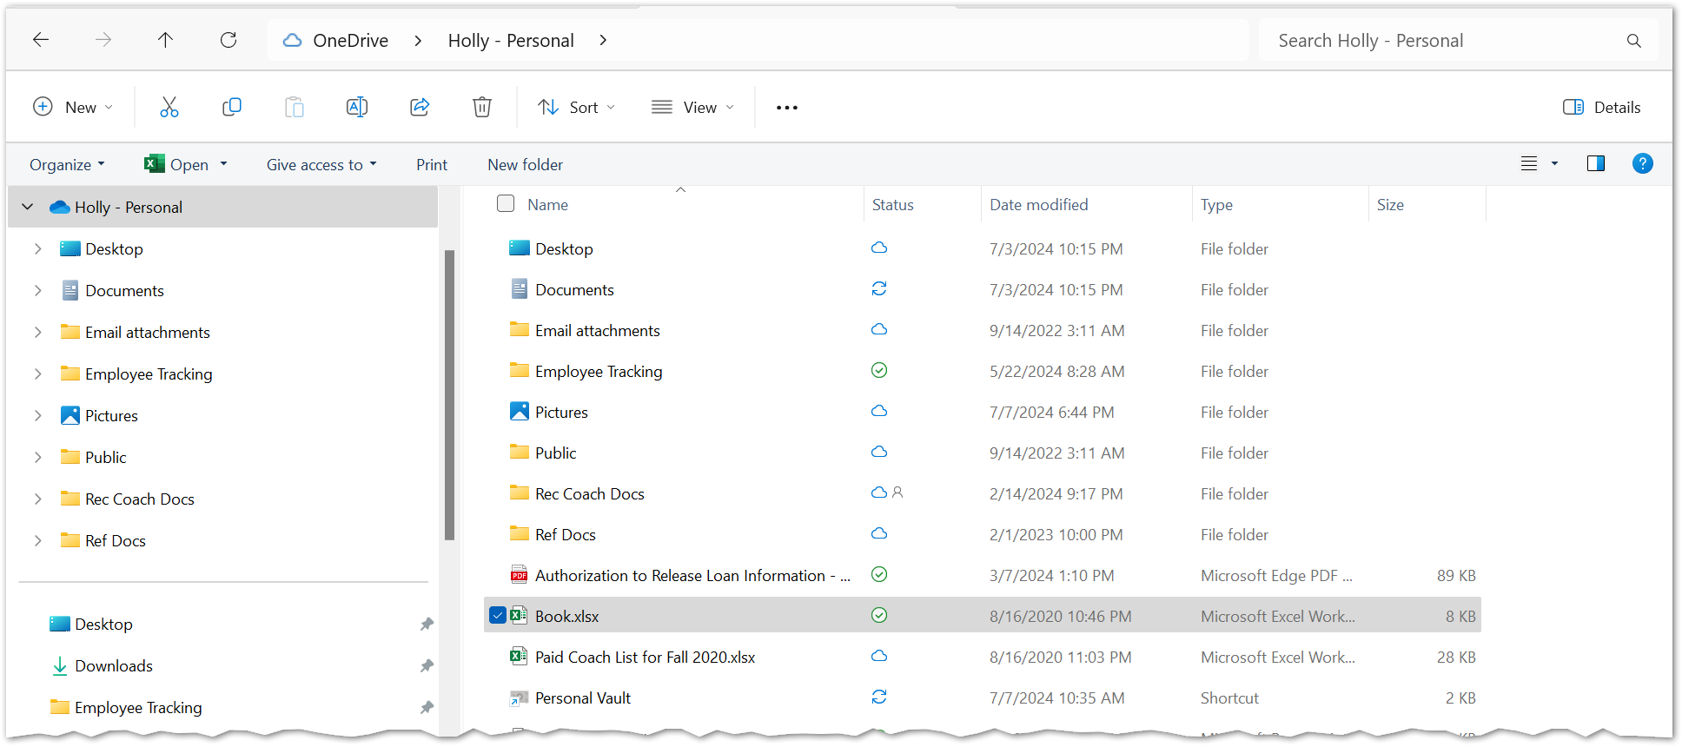

Sync Folders
NOTE: Move files/folders to OneDrive from your U drive, or other location, rather than syncing. Syncing is useful AFTER your files are in OneDrive, so that you have easy access to them on your computer. Remember, a VPN connection is required to access the U and F drives.

- Select the OneDrive cloud icon in your Taskbar in the notification area.
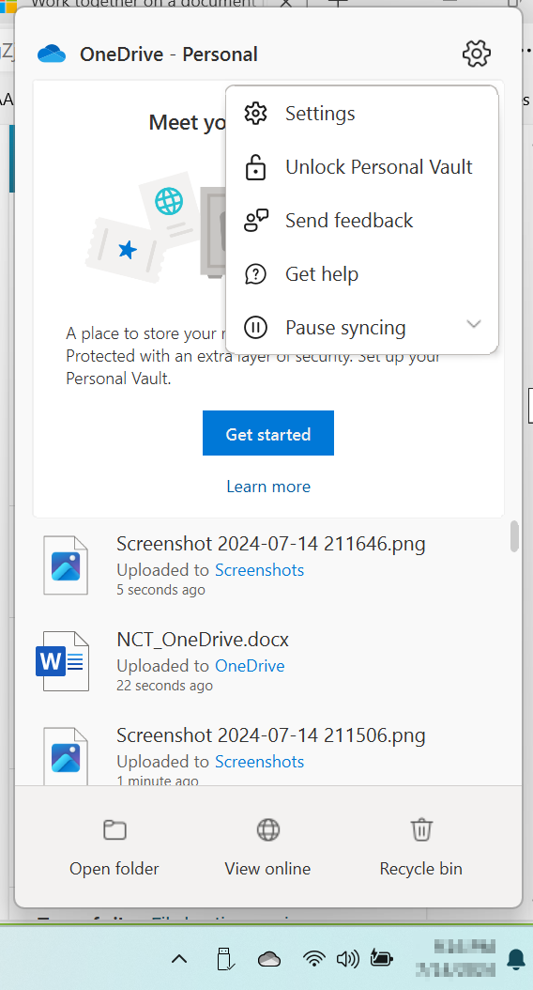
1
3
2
- Choose the Help and Settings (gear) button.
- Choose Settings.
- Select the Account tab.
- Select Choose folders.
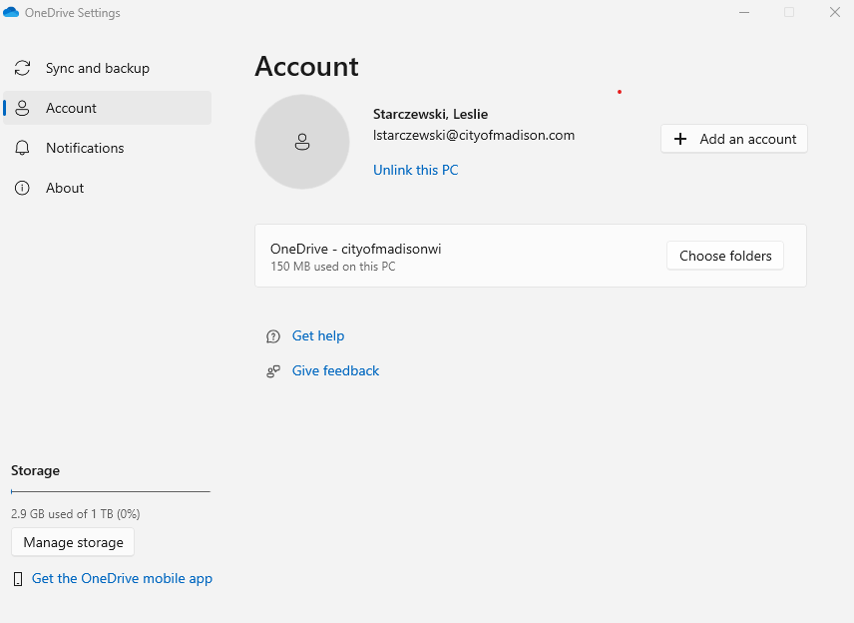
5
4
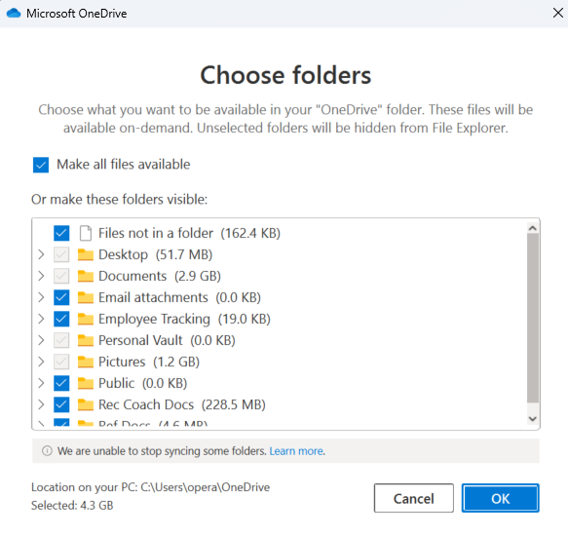
- In the Choose Folders dialog box, check the folders you want to sync, and uncheck any folders you don't want to sync to your computer and select OK.
6

QUESTION: Should I sync my U Drive with OneDrive?
You must move the files and folders in your U: drive to OneDrive for them to sync to the OneDrive cloud. You cannot sync directly from the U: drive. Remember, a VPN connection is required to access the U and F drives.

Manage Backup Folders
- Select the OneDrive cloud icon in your Taskbar in the notification area.
1
3
2
- Choose the Help and Settings (gear) button.
- Choose Settings.
- Select the Sync and backup tab.
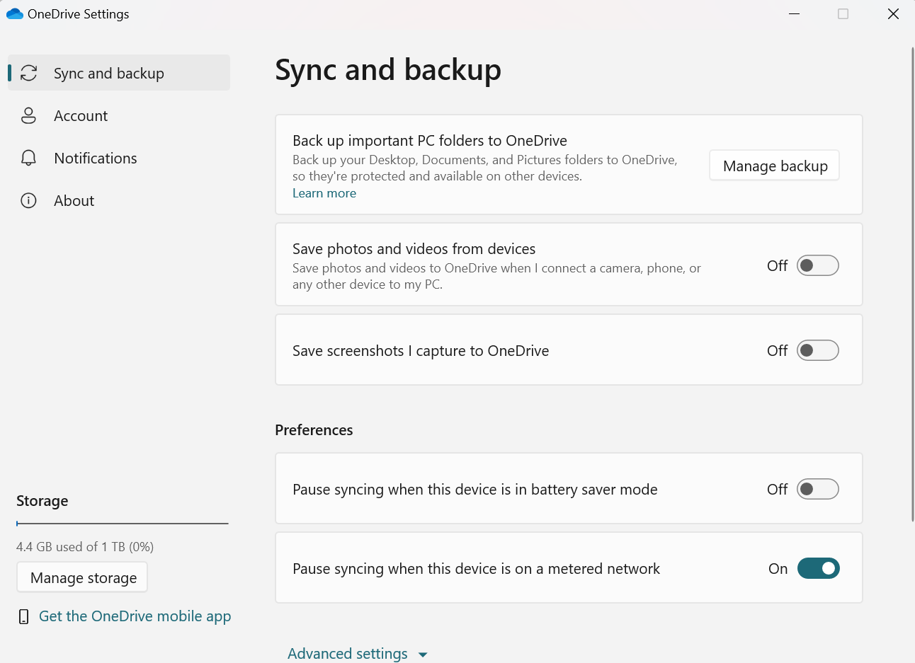
5
4
- Select Manage backup.
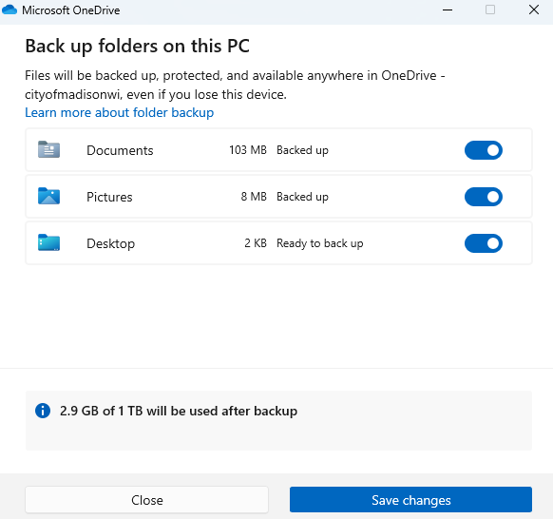
- In the Backup folders on this PC dialog box, toggle to the “ON” position any folder that is set to not back up, and then select Save changes.

6

