

Microsoft Training: Teams in MS Teams


Table of Contents
The Teams App 1
Teams App Screen Elements 1
Customize the App Bar 1
The City’s Version of Teams 1
Teams in Microsoft Teams 2
What is a Microsoft Teams “Team”? 2
Team Types 2
Requesting a Team 2
Teams Roles 3
Owners vs. Member 3
Moderators 4
Customizing Where You Access a Team 5
Switch to Separate View 6
Channel Overview 6
What is a Teams Channel? 6
Channel Screen Overview 7
Viewing Channels 8
Hide Channels 8
Show Hidden Channels 8
Pin a Channel to Favorites 9
Channel Notifications 10
Customize Channel Notifications 10
Notification Pro Tips 11
Channels Tabs 11
Expand a Tab 11
Open a Tab in a New Window 13
Channels Communication Overview 13
Teams Communication Rules & Requirements 13
Channel Messages 13
Posts vs Conversations 13
Post Actions 15
Post in a Channel 15
Reply to a Post 16
Conversation Actions 16
Add a Channel Conversation 16
Reply to a Conversation 17
Customizing Messages 18
Draw Attention to Your Message 18
Insert a Link 19
Send with High Importance 19
Interacting with Messages 20
Reply with a Reaction 20
Open Messages in a New Window 20
Save a Message 20
Delete Messages 22
Channel Files 22
Sharing Files with Your Team 22
Upload a Channel File 22
Add a Channel Message File 23
Sharing Files Outside of Your Team 24
Accessing Channel Files 26
Access Channel Files from the Teams App 27
Access Channel Files from SharePoint 28
Access Channel Message Files & Links 28
File Management Pro Tips 29
Archiving Teams 30

Disclaimer Notice
Microsoft frequently updates products, often rolling out changes in user interface (UI) and design. We keep our Microsoft support documentation current by updating it periodically. Even though buttons, menus, or windows may look slightly different on your screen, the fundamental steps, workflows, and concepts explained here should still apply. For these reasons, and so that you are accessing the more current version, please save the link to this guidebook rather than downloading it.

Teams in Microsoft Teams

What is a Microsoft Teams “Team”?
A team is a group of people in your organization pulled together for a shared purpose or goal. Teams can represent departments, workgroups, projects (internal or customer-facing), or initiatives. In Microsoft Teams, a Team is your digital workspace – a collection of people, content, and tools.

Team Types
The City uses two types of Teams:
- Private – Only invited members can view and collaborate within the Team.
- Public – Anyone with a City IT-managed M365 account can view and collaborate within the Team.

Requesting a Team
Teams are SharePoint sites with Teams enabled. You may need a new team when your work has its own purpose, people, and permissions that differ from an existing Team, such as a new workgroup, project, or initiative.
A new Team includes:
- A shared mailbox (which can function like a distribution list)
- A shared calendar
- File storage in a SharePoint site
- Optional Planner integration

If you only need space for a new topic, ask the Team owner to create a new channel instead of requesting a new Team.

To request a new site – or to enable Teams on an existing SharePoint site- submit a request through the IT Service Center. In the request, select: “Teams Enabled Site” in the Content Area Type box. IT will meet with you and your agency portfolio manager to determine the best solution for your needs.

Requesting a Team (Continued)
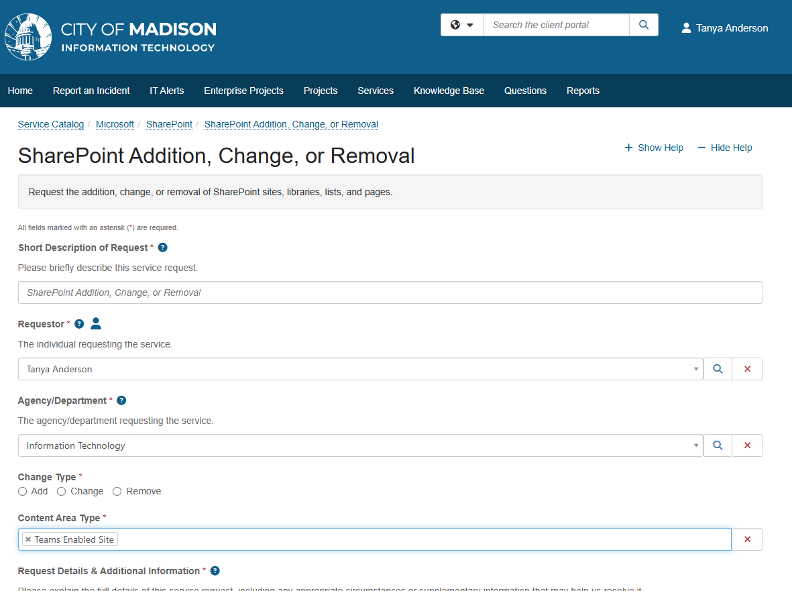

NOTE: People outside our organization can be added to your Team as guests if the Team’s settings permit it. Submit a guest user request through the IT Service Center.

Teams Roles

Owners vs. Member
Each Team has owners and members.
- Owners manage the Team. They can create Teams and Channels, configure settings, and control permissions. A team should have a minimum of 2 owners.
- Members are anyone added to the Team. They can collaborate, share files, and participate in conversations.

Here’s more detail about what owners and members can do:

Activity | Owner | Member
Create, upload, edit, and delete any file and folder | Yes | Yes
Edit or delete their own messages | Yes | Yes
Edit a message they didn’t send | No | No
Delete a message they didn’t send. | Yes | No
Create or update channels | Yes | No
Delete or restore channels | Yes | No
Add or remove apps | Yes | No
Upload custom apps | Yes | No
Create, update, or remove tabs | Yes | No
Create, edit, or delete tags | Yes | No
Set channel moderation preferences | Yes | No

Moderators
By default, team members can add and respond to messages in a channel. Team owners can assign a moderator to limit how members communicate in a channel.

Moderators can:
- Post to a channel, and react and reply to posts in a channel
- Add and remove team members as moderators
- Control whether team members can reply to existing channel messages

Note: Channel moderation is not available for the general channel.

The Teams App

Teams App Screen Elements
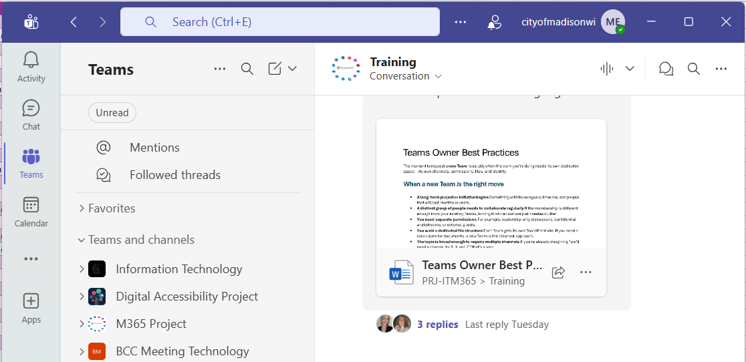
2
3
4
5
1
- App Bar – Select an icon to open different areas of the app. Teams calls each area a view.
- List Pane – See view-specific things like teams, chats, and notifications. Select items to open them in the main content area.
- Main Content Area– See the main parts of the app based on the view you select.
- Search Box – Find things that are associated with your Teams app, OneDrive, and Teams channels such as messages, files, and meetings.
- Account Manager – Set your status and change your profile information.

Customizing the App Bar
- To change the order of the icons: Select and drag an icon to a new location.
- To remove an app: Right-click its icon and choose Unpin.
- To open a view or app in a new window: Right-click its icon and choose Open in new window.
- To add an app: Select View more apps (…) and select an app. To keep the app’s icon on the App bar after closing the app, right-click (instead of selecting) the app and select Pin.

The City’s Version of Teams
The City uses a special version of M365 called Government Community Cloud (GCC). This means that the City’s version of Teams may not look the same as M365 help articles you find online or may not have some of the same features.

Customizing Where You Access a Team
You can view Teams you’re a member of in two different ways in the app - with combined view or with separate view.
- Combined view lists all chats, Teams, and channels in the Chat List pane. It also allows you to group conversations together in custom sections. This is the default view.
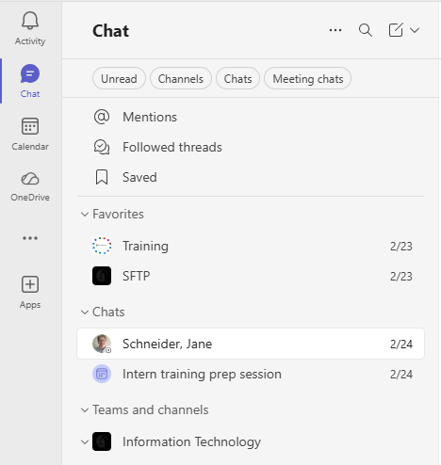

- Separate view separates Teams from chat messages and adds a Teams icon to the App bar. When you apply this view, you access chat messages by selecting Chats and Teams by selecting Teams from the App bar.
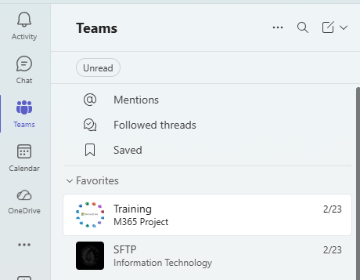

Customizing Where You Access a Team (continued)

Switch to Separate View
- Select Settings and more (…) next to your profile picture on the top bar of the app.
- Choose Settings.
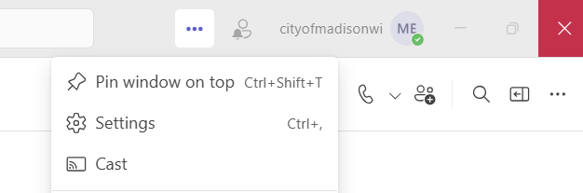
2
1
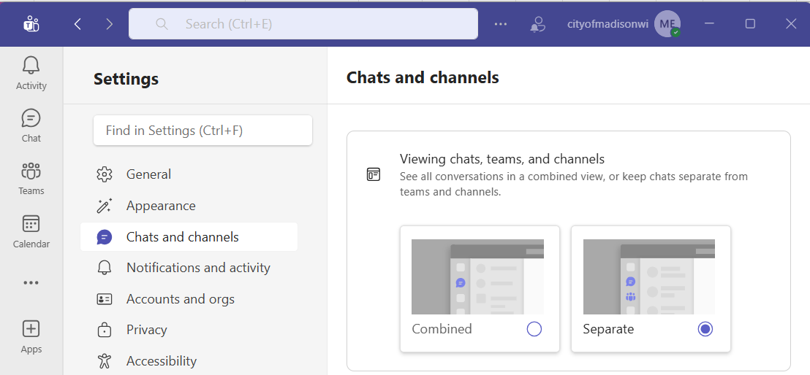
- Select Chats and channels from the Side Pane.
4
3
- Under Viewing chats and channels, choose either Combined or Separate.

Channel Overview

What is a Teams Channel?
Channels are spaces within a Team where members can focus communication, meetings, and file sharing on a single topic. When a Team is first created, a general channel is also automatically created. Team owners can add more channels to focus on additional topics related to the overall goal and purpose of the Team.

If you read Teams articles online, you may see that Teams offers different types of channels. The City uses standard channels only.

Channel Screen Overview
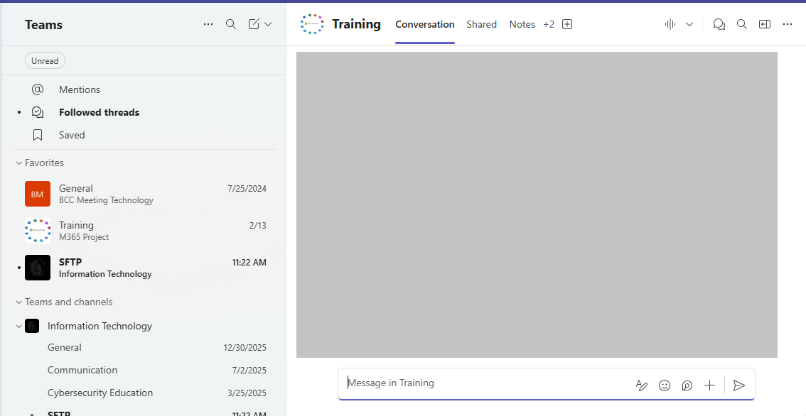
6
4
5
3
2
1

- List options: Customize sections and notifications, search for content, create new messages, and add section to the List Pane.
- Filter View: Filter content by unread, followed, saved threads and by @mentions
- Teams and Channels: Open and view teams and channels.
- Tabs: Access different areas inside a channel.
- Content Area: See different areas of the app based on the tab you open.
- Channel Options: Start a new instant meeting, shows threads (in Conversation View), and open channel details and options.

Viewing Channels
The team owner decides which channels you’ll automatically see and which channels are hidden. You can choose which channels you want to see by following the steps in the subsections below.

Hide Channels
Hide a channel to remove it from the Teams List. You will still get notifications for
- Personal @mentions
- Tag mentions
- Replies to followed threads and posts
Hiding a channel does not change the settings you apply in the Channel notification settings.
To hide a channel:
- Hover your mouse over (or tab to) a channel in the List Pane.
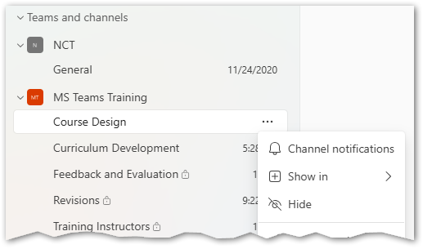
1
3
2
- Select the More channel options (…) button.
- Select Hide.

Show Hidden Channels
Move a hidden channel back to the Teams List Pane.
- Select See all channels.
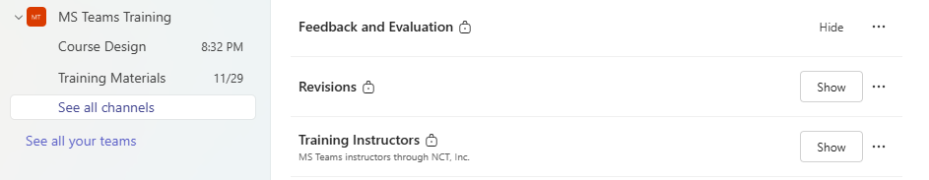
2
1
- Find the channel you want to unhide and select the Show button.

Pin a Channel to Favorites
Pin a channel to favorites to add it to the top part of the Teams List Pane.
- Hover your mouse over (or tab to) a channel in the List Pane.
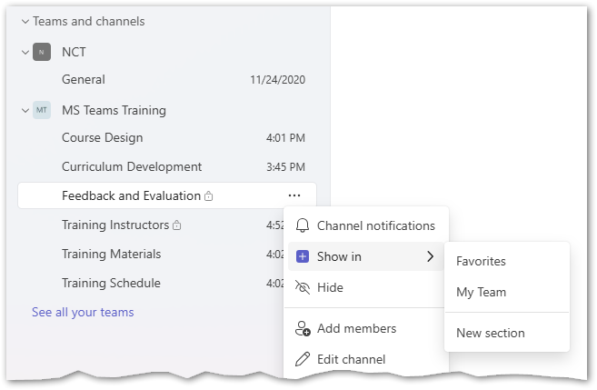
3
2
1
- Choose the More channel options button.
- Select Show in, then choose Favorites.
- Select the channel from the List Pane to open it.
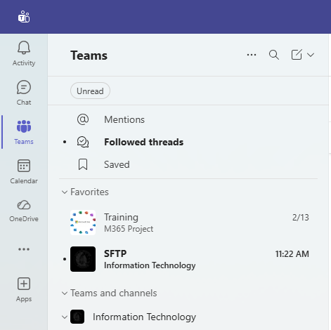
4

Channel Notifications
Some channel notifications are set up as defaults, but you can turn them off or customize where you want to see them by going to the Teams app settings. The default notifications occur when:
- Someone replies or reacts to a channel message you wrote, replied to, or follow
- Someone @ mentions you
- Someone tags a group you’re in

You can also customize the notifications for each channel. Here are the ways you can customize notifications:
- Notify me for all messages: Get notified every time someone creates a channel message.
- Include thread replies: Get notified every time someone replies to a channel message.
- Follow all new threads: Get notified every time someone responds in a thread.
- Off: Turn off notifications for the setting it’s applied to.
You can choose one or more of these locations to receive the notifications:
- Show in Activity: Get a notification in your Activity feed.
- Show in Activity and banner: Get a notification in your Activity feed and a pop-up on your screen.
- Off: Turn off all notifications for the setting you apply it to.

Customize Channel Notifications
- Hover your mouse (or tab to) the channel in the List Pane.
- Select More channel options (…).
- Choose Channel notifications.
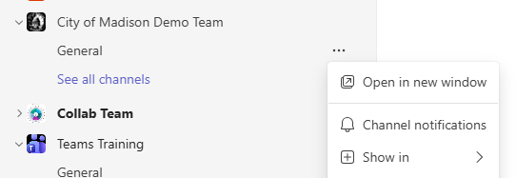
3
2
1

Customize Channel Notifications (continued)
- Customize the channel notification settings.
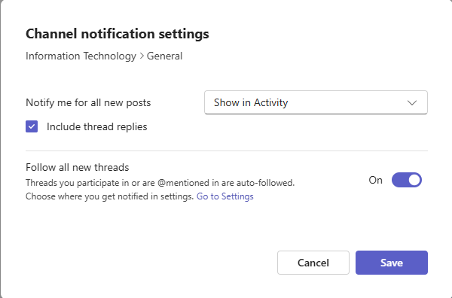
- Select Save to apply the changes.

Notification Pro Tips
Notifications can either help or hinder your team. Adjusting these settings lets each person create a workspace that supports their focus and flow rather than disrupting it:
- Hide and mute channels that don’t directly impact your work.
- Turn off banner notifications for nonurgent updates to avoid unnecessary distractions.
- Follow key channels to ensure you see critical updates right away.
- Adjust @mention settings to limit unnecessary pings, especially on busy teams.
- Use do-not-disturb during heads-down work sessions.
- For a particularly important channel, you can configure the settings to automatically follow any new thread that gets created. See the Threads piece later in training.

Channel Tabs
Channel tabs provide a centralized location for accessing pages, documents, tools, and apps for each Teams Channel. Tabs integrate tools and content, enhance collaboration, and streamline access. Team owners customize the channel’s tabs with relevant apps, files, and websites. Not all channels will have the same tabs.

Expand a Tab
Hide the navigation pane to make a selected tab wider.
- Open the tab you want to expand.
- Right-click the tab name or select the arrow next to the tab name.
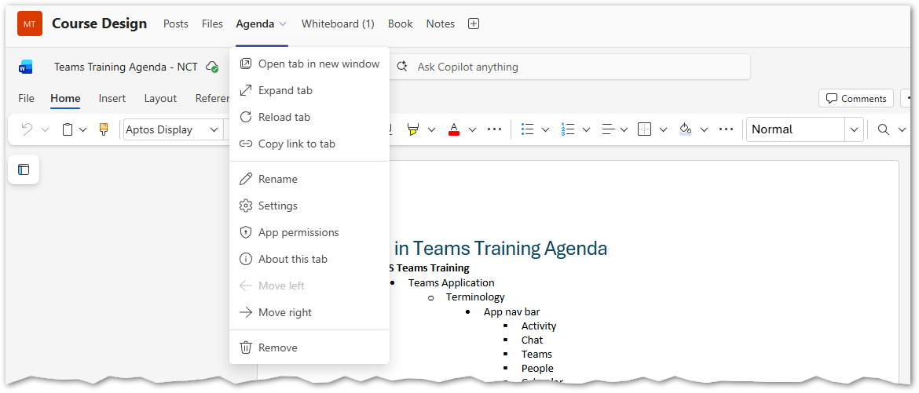
24
34
- Select Expand tab to make the tab larger.
- To return to the tab sized-window, select the Collapse tab button from the top right corner of the window.
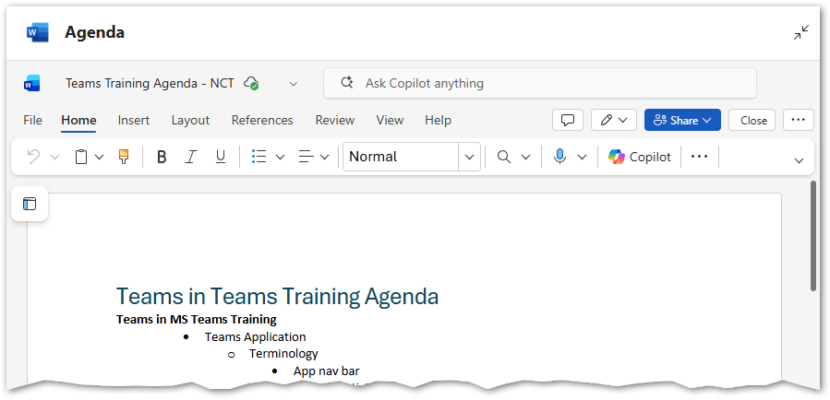
4

Channel Tabs (continued)

Open a Tab in a New Window
- Right-click the tab.
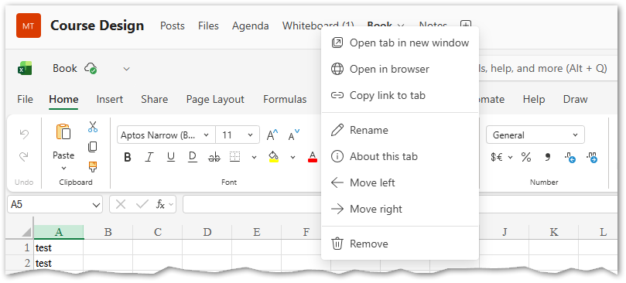
24
14
- Choose Open tab in new window.

Channels Communication Overview

Teams Communication Rules & Requirements
Where you communicate within the Teams app determines what your communication is called and the rules governing it. Communication within a Team is called a post or conversation. Direct messages with another person or a select group of people are called a chat.
- Posts and conversations are retained for 7 years and may be released in response to a request of public records or as part of litigation discovery.
- Chats are meant to be transitory and are retained for approximately 24 hours. Transitory means they are non-substantive and do not initiate, sustain, evaluate, or document decision making or policy. Chats that do include policy or decision-making content must be downloaded or otherwise preserved and may be released as part of a public records request or litigation discovery.

Channel Messages
The channel you’re a member of may be in one of two different layouts: posts or conversations. The team owner decides which layout the channel uses.
Read the following subsections to learn about the differences between the layouts and how you create and respond to messages depending on the layout.

Posts vs Conversations
Posts
- Best use case: The posts layout is best for forums and announcements, where there may be few, if any, replies. (Teams calls replies “threads”.)
- Threads: Message responses are directly underneath the posts.
- Formatting new message: The message formatting options automatically open when you choose to draft a new message, including a line to add a subject. This sets a standard for adding a subject to and using built-in formatting in all posts.
- Feed: When someone responds to a post, channel members will see the message at the bottom of their message feed as if it were a new post.
- Example image:
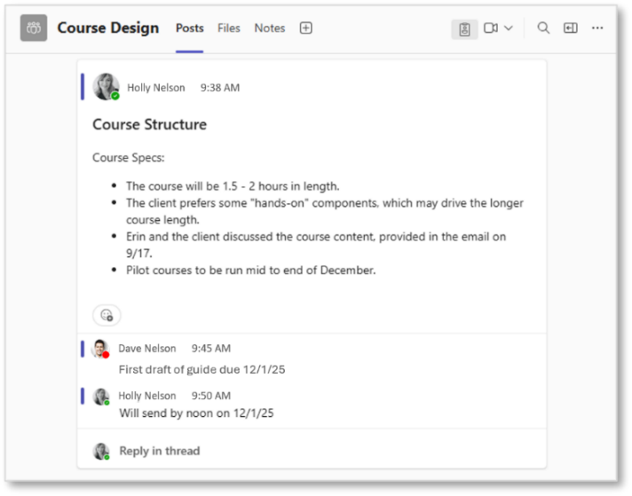

Channel Messages | Posts vs. Conversations (continued)
Conversations
- Best use case: The conversation layout is best for back-and-forth discussions, as responses are kept separate from the main message in a side panel. (Teams calls replies “threads”.)
- Threads: Messages have a link to responses beneath them. Selecting the link opens a side panel that lists the responses.
- Formatting new message: You must open the formatting options when drafting.
- Feed: Messages are listed in the order they were added, regardless of when people respond. The message at the bottom of the conversation feed is always the most recent one added to the channel.
- Example image:
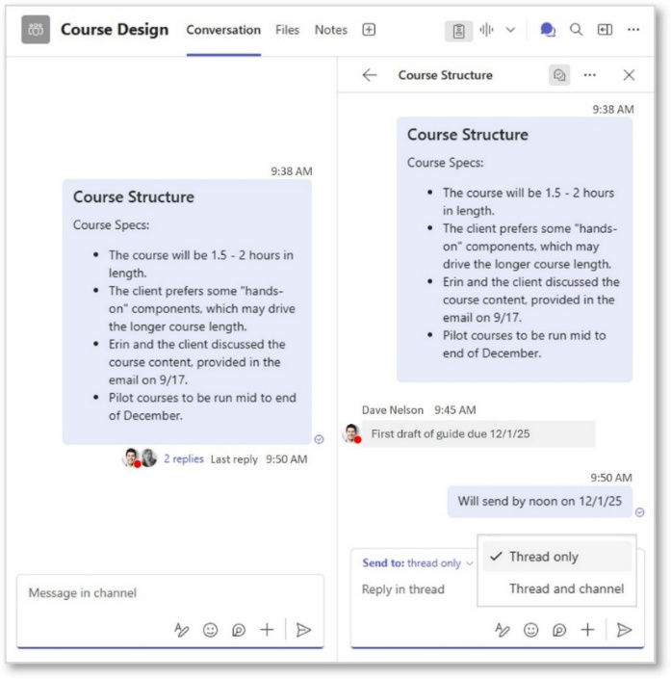

Post Actions

Post in a Channel
- Go to the Posts tab in the channel.
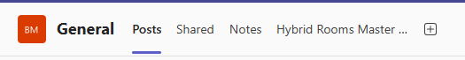
- Select Post in channel.

- Add a subject. Use the built-in formatting features to craft an accessible post. Select Post to add your message to the channel.
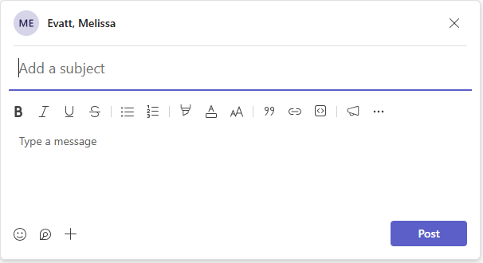

Reply to a Post
- Select Reply in thread underneath the post you want to reply to.
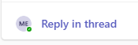

Conversation Actions

Add a Channel Conversation
- Go to the channel’s Conversation tab.
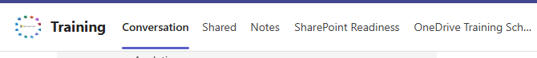
1
- Select the Formatting button in the Message box.
2
- Add a subject.
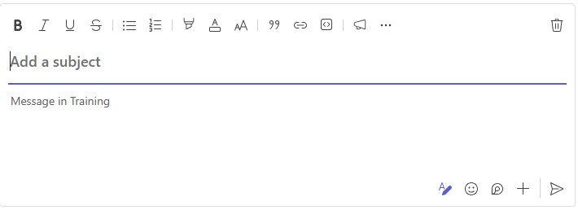
5
4
3
- Use the built-in formatting features to craft an accessible conversation.
- Select Send to add your message to the channel.

TIP: Adding a subject and using built-in formatting features, like bulleted lists, makes messages more organized and accessible.

Reply to a Conversation
- Hover your mouse over a conversation.
- Select Reply in thread. This opens the threads panel.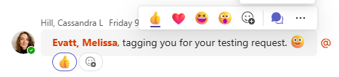
2
- Enter message and select Send to add a thread to the threads panel.

Reply to a Conversation (continued)
OR
- Select the arrow next to Send to: thread only and choose Thread and channel. This adds your response to the conversation’s thread panel and to the Conversation feed. It’s a good choice to use when you have reached a decision or outcome. Replies will still be added underneath your message in conversation’s thread panel.
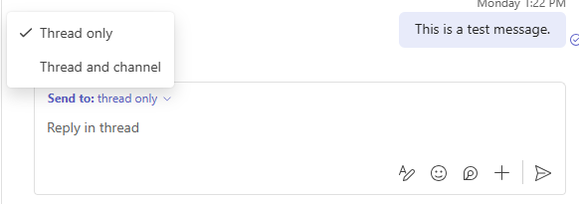
4

Customizing Messages
Complete the steps in the following subsections from the body of a message you’re composing. The message view applied to the channel doesn’t affect how you complete each task.

Draw Attention to Your Message
Draw attention to your messages with the @mention feature. By default, this sends a notification to people’s Activity feed. However, channel members may have changed their notification settings to not receive certain types of notications.

You can mention individual people, people included in a channel tag, or channel member.
To add an @mention:
- Type @ on your keyboard and begin to enter the name of the person, group, or channel tag.
- Choose who you want to notify from the listed suggestions.
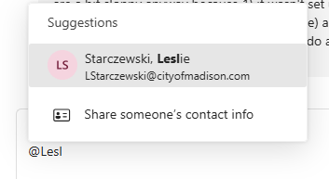
2
- Repeat this step for each person, channel, or channel tag.
- Successful @mentions show the person’s name in blue.
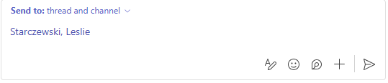
4

Customizing Messages (continued)

Insert a Link
Sharing a link in a channel message adds it to the In Message section of the channel’s Share tab.
- Select the Formatting options button.
- Select Insert link from the formatting toolbar.
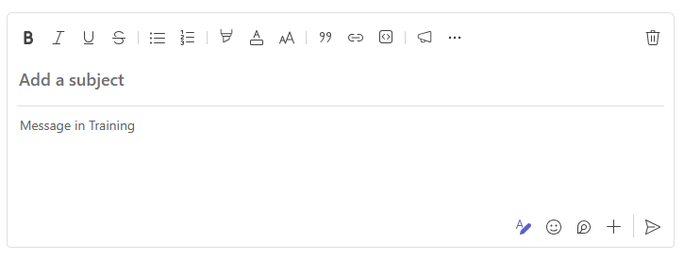
2
1
- Enter descriptive link text in the Text to display field.
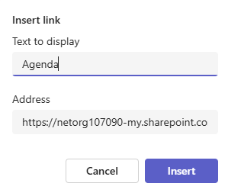
5
4
35
- Paste the destination URL into the Address field.
- Select Insert to add the link text to your message.

Send with High Importance
Sending a message with High Importance adds the word IMPORTANT in all caps and red to the top of your message. It doesn’t change how your message is sent.
- Press CTRL-SHIFT-I in a new message.
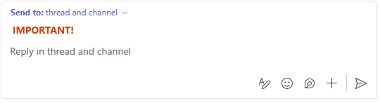

Interacting with Messages
Follow the steps below to interact with a channel conversation or post.

Reply with a Reaction
- Hover your mouse over the message that you want to react to.
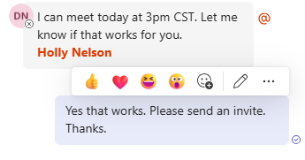
1
2
- Choose a reaction.

Open Messages in a New Window
- Hover your mouse over the message you want to open in a new window.
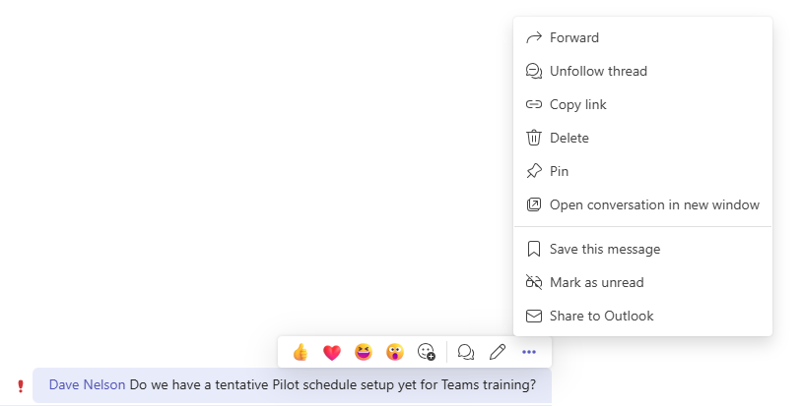
3
2
1
- Select More Options.
- Choose Open conversation in new window or Open post in new window. The entire conversation or post and replies to it will pop out to a new window.

Save a Message
Saving a message adds a Saved button to the top of the Teams List Pane in Separate view and to the top of the Chat List Pane in Combined View. (Read the Customize Access to Your Teams section of this guidebook to learn more about Teams Views.) This feature lets you easily access important messages without having to search the channel’s message feed.
To save a message:
- Hover your mouse over a message.
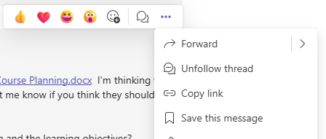
3
2
1
- Select More options (…).
- Choose Save this message. This adds a bookmark icon next to the message’s timestamp.
- To unsave a message, select More Options and choose Unsave this message.
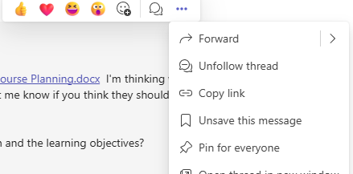
4

Interacting with Messages | Save a Message (continued)
To open a saved message:
- Select the button to open a list of saved messages.
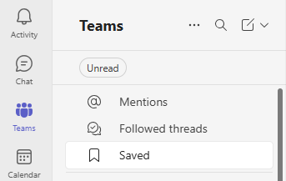
1
- Select a message from the list to open it in main content area on the screen. You’ll see all replies and reactions to the message after you save the message in this area, even when they’re sent after you saved the message.
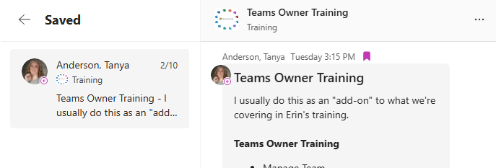

Delete Messages
You can delete messages you added in channel. Team owners can also delete your channel messages. City IT saves every channel message for seven years, regardless of whether someone deleted it.

Channel Files

Sharing Files with Your Team
You can share a file by uploading it to the channel and by sharing it in a channel message.

Upload a Channel File
Uploading a file to a channel
- Moves the file to that channel
- Adds the file to the All documents section of the channel’s Shared tab in the Teams app and to the channel’s folder in SharePoint
- Gives channel members permission to edit it
To upload a file:
- Go to the channel’s Shared tab.
1
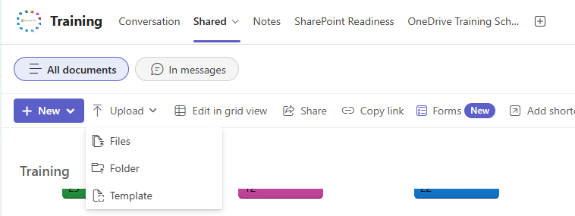
3
2
- Select Upload from the toolbar.
- Choose the files, folder, or template you want to upload.

Add a Channel Message File
Sharing a file in a channel message
- Keeps the file stored in its original location, such as in your OneDrive
- Adds the file to the In messages section of the channel’s Share tab
- Gives channel members read-only access to the file by default
Pro Tip Upload a file to the channel before sharing a link to maximize collaboration.

Channel Files | Sharing a File with Your Team, Adding to a Message (continued)
To share a file link:
- Select the Apps and actions (+) button in a new message.
- Choose Attach file.
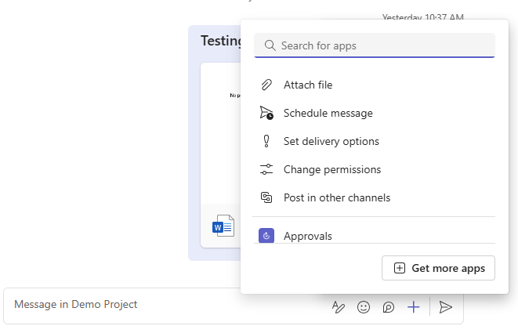
2
1
- Choose a recently accessed, cloud, or channel file or a file on your device.

Sharing Files Outside of Your Team
As a channel member, you can move channel files to another location, such as OneDrive, another channel, or another team.
Moving a channel file
- Transfers it to a new location
- Removes it from the channel
- Keeps its revision history
- Allows you to keep sharing it with the same channel members
To move a channel file:
- Hover your mouse over (or tab to) a file.
- Select More Actions (…).
- Choose Move to from the menu to open the Move to window.
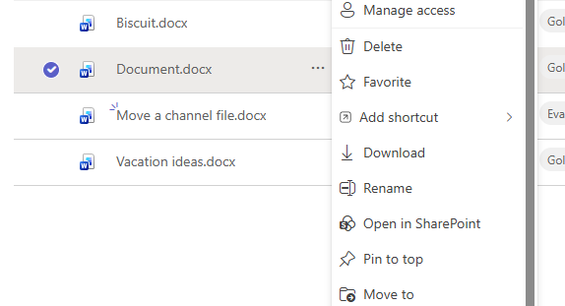
1
2
3
Channel Files | Sharing Files Outside of Your Team, Moving a File (continued)
- Choose one of these options from the window’s side panel:
  - My files to move the file or folder to your OneDrive
  - Shared to move the file or folder to a shared folder
  - Quick access to move the file or folder to a team you frequently access
  - More places to move the file or folder to a team not listed in the Quick access section
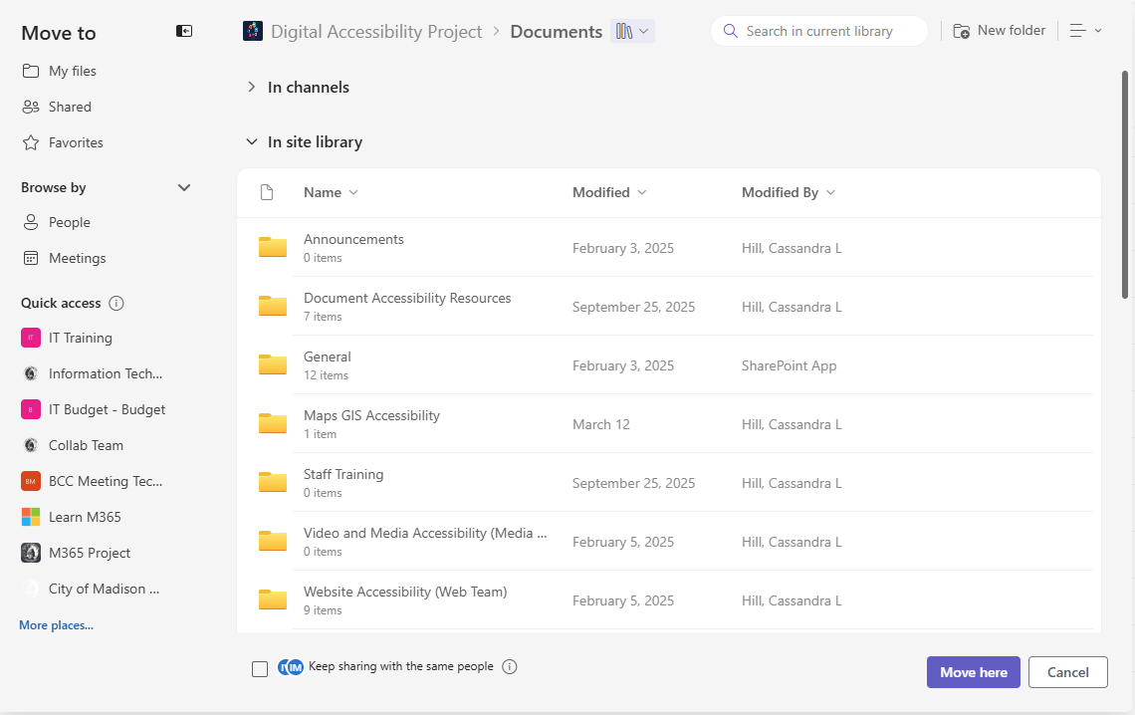
6
7
5
4
- Choose the folder that you want to move the file to.
- Select the Keep sharing with the same people checkbox to continue sharing with channel members and notify them that the file has moved.
- Select Move here.
NOTE: We recommend not using the Keep sharing with the same people feature when moving a file to a different channel. This would change the permissions on that file only to not match the permissions in the destination channel. All channel files should have the same permissions levels for everyone, so it’s best to avoid this feature.

Accessing Channel Files
- Channel files and folders are located in the channel’s folder on the team’s SharePoint site. You can access them from the SharePoint folder and from the All documents section of the channel’s Shared tab.
- Channel message files, folders, and links are files, folders, and links that someone shared in a channel message. You can access them from the In messages section of the channel’s Shared tab.
Read the following subsections to learn how to access this type of content.
Accessing Channel Files (continued)

Access Channel Files from the Teams App
- Go to the channel’s Shared tab.
- Make sure the All documents section of the tab is open.
1
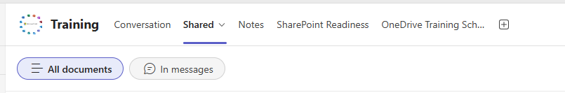
2
- Hover your mouse over (or tab to) the file.
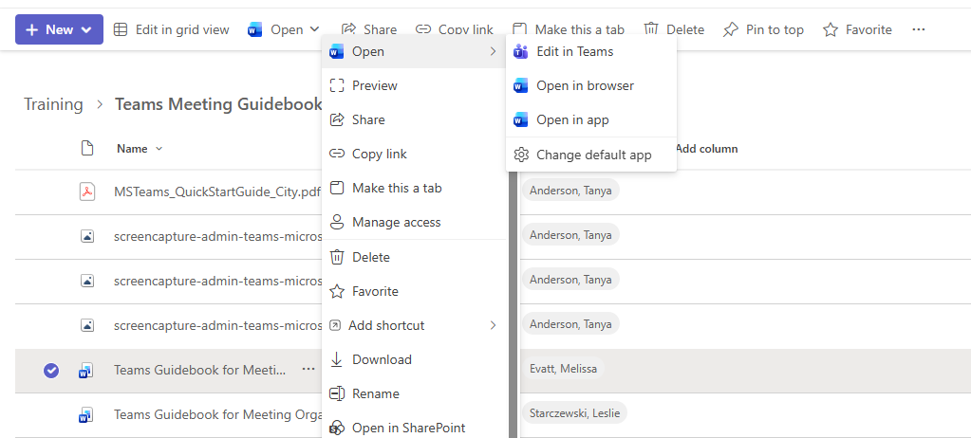
6
5
3
4
- Select More Actions (…).
- Choose Open.
- Choose one of the following options to open and edit a file. All changes you make will update the file in the channel.
  - Edit in Teams – Open and edit the file in the Teams app
  - Open in browser – Open and edit the file in the online version of the file’s app in a web browser. Microsoft recommends using Edge, Chrome, or Firefox in windows 11.
  - Open in app – Open and edit the file in the file’s desktop app on your device.

Access Channel Files from SharePoint
- Go to the channel’s Shared tab.
- Make sure the All documents section of the tab is open.
1
2
- Hover your mouse over (or tab to) the file.
4
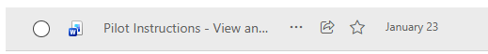
3
- Select More Actions (…).
- Choose Open in SharePoint from the menu.
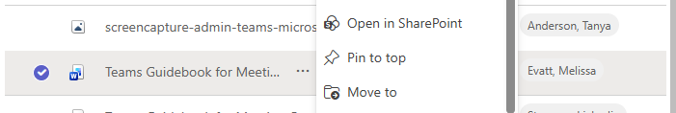
5

Access Channel Message Files & Links
- Open the channel’s Shared tab.
1
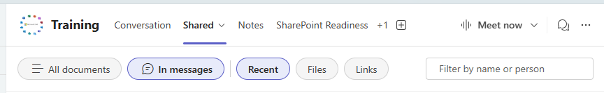
2
- Go to the tab’s In messages section either by selecting it with your mouse or by pressing Tab until you get to the All documents option in the page’s Filter List Tab section, pressing the left arrow key to go to In message, and pressing Enter.

Accessing Channel Files | Accessing Channel Message Files and Links (continued)
- Hover your mouse over (or tab to) a file.
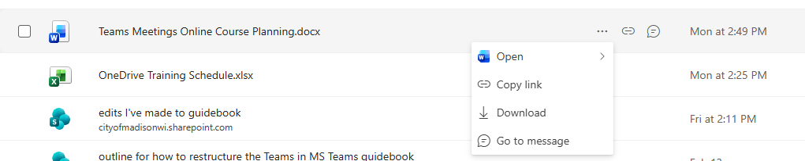
4
3
- Select (or press the right arrow key and press Enter once you get to) Show more actions for this item (…).
- Choose one of the following options from the menu:
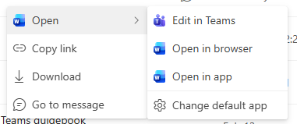
  - Open – Choose Edit in Teams, Open in Browser, or Open in app to open in the app where it was created. Choose Change default app to open to the file in a different, compatible app.
- Copy link – Copy a link to share.
- Download – Get a separate, private file just for you.
- Go to message – Open the original message that has the attached file, file link, or hyperlink.

File Management Pro Tips
Just as you would with your personal files, it’s important to keep files and documents organized and consistent so that everyone on the Team can easily locate the files they need. All documents in a Team can be organized from the Shared tab.

Recommendations for organizing Team files:
- Treat your files like a Shared Drive with clear organization rules and structure.
- Create a folder for each key topic or project (e.g., Client Presentations, Q2 Campaign, Team SOPs).
- Pin top-level files or folders for quick access.
- Use subfolders sparingly – limit to 3 levels of folders deep. There is a limit on the length of the folder path.
- Use date formats like YYYYMMDD to keep everything in chronological order.
- Stick to lowercase or title case, and decide on a consistent separator (e.g., dashes or underscores).
- Use the built-in file version history.
- Do a ROTII review every quarter.

See the IT Service Center articles – Best Practices for Naming Electronic Records and Where to Store Your Stuff.

Archiving Teams
When an MS Team is no longer needed or in use, it is archived.
All files are read-only.
You can download a copy, but cannot add, delete, or edit files in the Archived Team.
Please contact IT to ensure everything is fully and properly archived.

