SUBJECT: Mentorship Program – [MONTH 3] Update

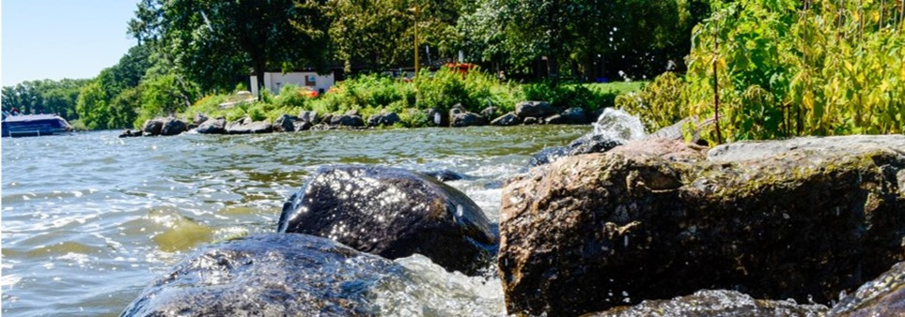
MESSAGE:

[MONTH 3] Forecasting:
Good morning

I am excited to forecast our next month and share some cool new resources that will continue supporting you all in your ongoing development.

Mid-Point Check In
I am so excited for our in person mid-point check in!
You should have received a calendar invite from me for [Date] from [Time] at [Agency] ([Address]).

This is a reminder to factor in up to 30 minutes for travel time and be open to carpooling.
Oh yea, as city employees you have access to reserve a city vehicle for transportation purposes as well.

Be prepared to…
- Continue building relationships across the mentorship cohort
- Learn more about yourself and others
- Have some FUN 😊

Recommended Resource(s)
Development discussions revealed that the skills we are interested in further developing, might include a list of ‘sub skills. One of the repeated ‘sub skills’ that we highlighted was feedback!

Whether feedback is on your list of ‘sub skills’ or not, it’s a GREAT and useful tool that allows you to
- Strengthen communication
- Build trusting relationships
- Create a healthy culture
- Increase engagement and collaboration
- Help you and others learn, grow, and develop

Look at the “Effective Feeback Resource Packet”. It’s broken up into the following 3 sections:
- Feedback Foundation
- Tips and Common Pitfalls
- Receiving Feedback

[MONTH 1] Resource: Individual Development Plan (IDP).
[MONTH 2]Resource: Skills Self-Assessment.

Gentle Reminder: Check-In Survey – [Hyperlink Survey Monkey You Created]
Thank you for [%] completion on our check in survey between [Survey Open Date] and [Survey Close Date].
If you have not completed this yet, please take less than 5 minutes to complete this brief survey to let us know how your experience has been so far. This will allow us to best support you in real time, adjust, and/or intervene, as necessary.

As always, it’s a pleasure to support you on your journeys of growth and development.
I look forward to us being in shared community as we continue great work.

Warm regards,
[Your Email Signature]

